Why?
This document lays out the key principles for DxD Groups. After a brief explanation of the DxD strategy as a whole, the remainder of the document unpacks those elements that turn a Group into a DxD Group, namely: gathering 2 – 10 people, having an apprentice/co-leader, holding each other accountable to Gospel Conversations, and Going in service to your campus, neighbors, and the nations.
How you tactically train your leaders will be between you and your campus leadership, but success in ministry for “groups” will be defined in terms of the content below. The metrics will be the number of DxD Group leaders; number of apprentices; number of DxD Groups; and the % of the average worship attendance in ongoing biblical community, i.e. non-DxD Groups.

What?
Key Concept: We are disciples of Jesus who multiply disciples with Jesus.
Key Text: Matthew 28.19-20
Go therefore and make disciples of all nations, baptizing them in the name of the Father and of the Son and of the Holy Spirit, teaching them to observe everything I have commanded you. And remember, I am with you always, to the end of the age.
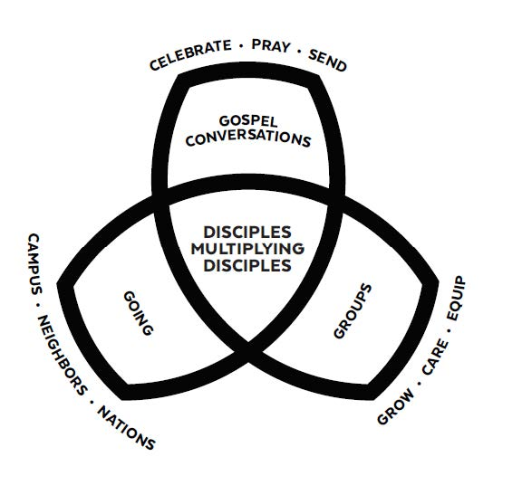
DxD strategy is simply a diagram and language designed to help our congregations understand Matthew 28.19-20. The only command in the text is make disciples with the participles go, baptizing, and teaching expounding how one is to complete the task of disciplemaking. The center of the diagram captures make disciples with the phrase “Disciples multiplying Disciples.” The three sets around the center elaborate the how: go is represented by “Going,” baptizing is represented by “Gospel Conversations,” and teaching is represented by “Groups.”
Our people are zealous for the Bible, and, on average, truly do seek to live their lives by it. We must help them see that this strategy is simply handles to help them unpack the Great Commission for their daily lives.

How: Groups
Key Concept: Groups are ongoing biblical communities that grow, care, and equip.
Key Text: Acts 2.42,46
They devoted themselves to the apostles’ teaching, to the fellowship, to the breaking of bread, and to prayer. Every day they devoted themselves to meeting together in the temple, and broke bread from house to house.

Groups represents the Great Commission’s teaching them to observe everything I have commanded you. The early church gathered daily focusing on the apostles’ teaching, fellowship, the meal, and prayer to help one another obey Jesus’ teaching. Our Groups will accomplish these things through the three categories: grow, care, and equip.
Grow should be understood primarily as growth in spiritual maturity. Certainly, it is good to grow in size by inviting the unconnected, particularly those yet to believe, into your ongoing biblical community; but, the stress is on spiritual maturity through the teaching of the Bible so that people will put that teaching into practice in their day-to-day lives.
Care consists of nurture, prayer for one another, and fellowship with those in the group. Care could be thought of most helpfully as hospitality and generosity toward one another.
Equip is the piece of Groups that aims unto something: disciplemaking. The teaching, care, and ministry within the Group should result in the “fruit” of group members making disciples in their daily lives. This task begins with prayer for who to disciple, and then inviting those individuals into our lives.
Groups are a necessary piece of the puzzle even though they are not DxD groups, yet. Not everyone invited to know the Lord is ready for the intentional training and multiplication of a DxD Group. Groups are a place to become known and loved through shared affinity and Bible teaching. As the saying goes: belonging leads to becoming; these Groups will be a place for the unconnected to “belong.”
Groups, generally, will be larger communities which do not lend themselves to the intentional training and multiplication of a DxD community. To introduce those features, DxD Groups are aimed at 2 – 10 people which will increase accountability, transparency, and multiplication.
The “Core to Disconnected” tool is a way to help us illustrate discernment and emphasis. For example, your apprentice(s) will be a part of your core whereas your DxD Group will be your committed community. Other Groups and the worship gatherings will be your Community and Connections. With the tool, leaders are able to be intentional at different levels with a different focus depending on the community: from deep intimacy and multiplication with apprentice(s) and DxD Groups to general affinity and mission with Groups and worship gatherings.
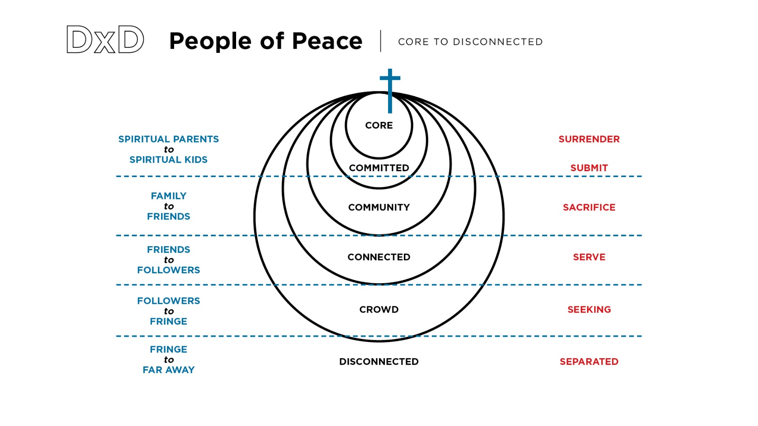
How: Apprentice
Key Concept: Apprentices are those individuals that the DxD leader intentionally invests in for reproducing DxD leaders and multiplying groups.
Key Text: 2 Timothy 2.2
What you have heard from me in the presence of many witnesses, commit to faithful men who will be able to teach others also.
The beauty of this sentence is that we see the vision of multiplication cast across four generations in such brevity. Multiplication matters and it comes from the intentional investment of current leaders into future leaders; it is not accidental. The mindset shift can be a difficult one: from teaching crowds as the emphasis and focus, to training a few people in order to reproduce. Teaching moves from success being defined as content transfer to success being defined as modeling, equipping, and empowering others to teach. Without this intentionality, we will certainly see a great addition of Groups, but we will fail to see the disciplemaking multiplication we desire.
The vision may go something like:
You have a group of 30 people that you teach the Bible to weekly. You invite 1 or 2 individuals from that group to learn how to live godly lives in addition to teaching and leading others to do the same. You and these 2 new individuals invite along 5 other individuals so that you have a group of 8. With this new group of 8, you meet regularly to grow, care, and equip BUT you also debrief/train your apprentice, you serve with this group in the local community, you all volunteer to help preschool ministry at your campus, and you plan for someone to go on a global mission journey or pool money to support a missionary. You each hold each other accountable to put Scripture into practice and to be praying for and having Gospel Conversations regularly. This kind of accountability would be rare, if not impossible, in your 30-person group.
The multiplication happens when you leave this 8-person DxD group to start another OR your apprentice(s) leave with a few of the members of the 8-person group to start a new DxD group, taking an apprentice for themselves.
The “Timothy Principle” tool helps us think exponentially about discipleship. We begin by taking our apprentice with us in our ministry endeavors and daily life while unpacking his/her observations. We encourage and coach our co-leader/apprentice to begin investing in faithful people. A helpful memory device for discernment comes from Bobby Harrington in the Disciplesmaker’s Handbook. He describes the people we’re after with AFTeR: Available Faithful Teachable e Reliable. They are available to us in terms of schedule and life-business; they are faithful to the kingdom of God and the commission to make disciples; they are teachable in that they listen, understand, and attempt our training; they are reliable in that they can be counted upon to show-up and invest in the efforts of disciplemaking. With good discernment, those faithful people will be able to disciple others.
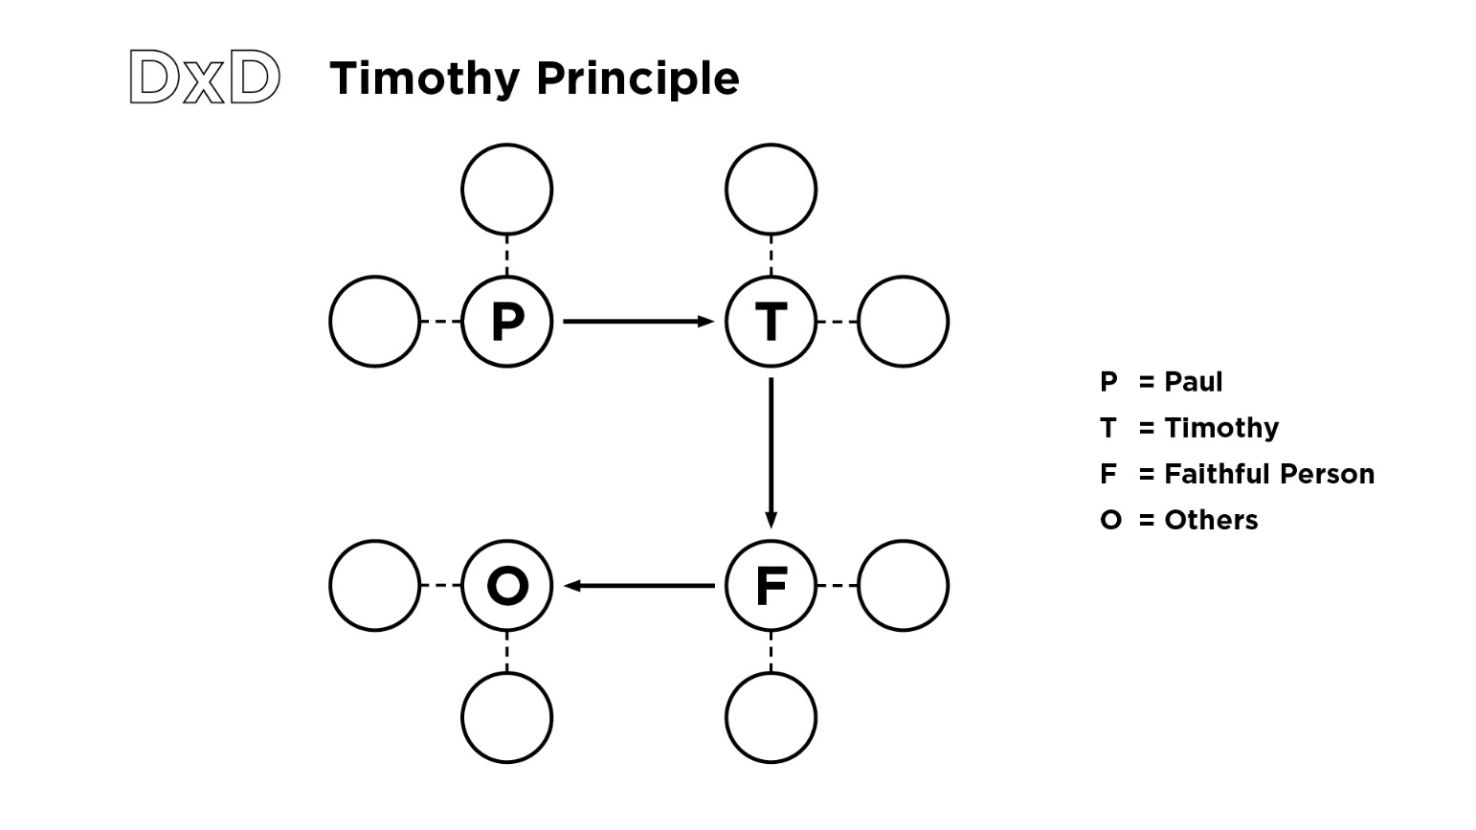
How: Gospel Conversations
Key Concept: Gospel Conversations mean sharing the good news of Jesus with the lost and searching, trusting the Holy Spirit with the results.
Key Text: 1 Corinthians 15.3-4; 1 Peter 3.15-16
For I passed on to you as most important what I also received: that Christ died for our sins according to the Scriptures, that the was buried, that he was raised on the third day according to the Scriptures
. . .
In your hearts regard Christ the Lord as holy, ready at any time to give a defense to anyone who asks you for a reason for the hope that is in you.
Our power rests in the good news of the gospel and in how that reality has affected us personally: redeemed us for new, true, eternal purpose. The hope that Peter has in mind is the truth of the resurrection which is the foreshadow of the future for the believer: raised to new life and everlasting community with the triune God and other believers. Our mandate is to bear witness; our triune God does the converting. Obedience is confident witness, not conversion.
Often it is helpful in addition to one’s personal testimony that they have a Gospel presentation tool. The value of the tool is that you can be ready anywhere, anytime with anybody to share your faith. “3 Circles” offers a simple, easily reproducible tool to have Gospel Conversations. While you may supplement this tool with other resources and tactics, “3 Circles” will be the common language used by Brentwood Baptist Church preachers in their sermons and will be a part of our core Gospel Conversations training.
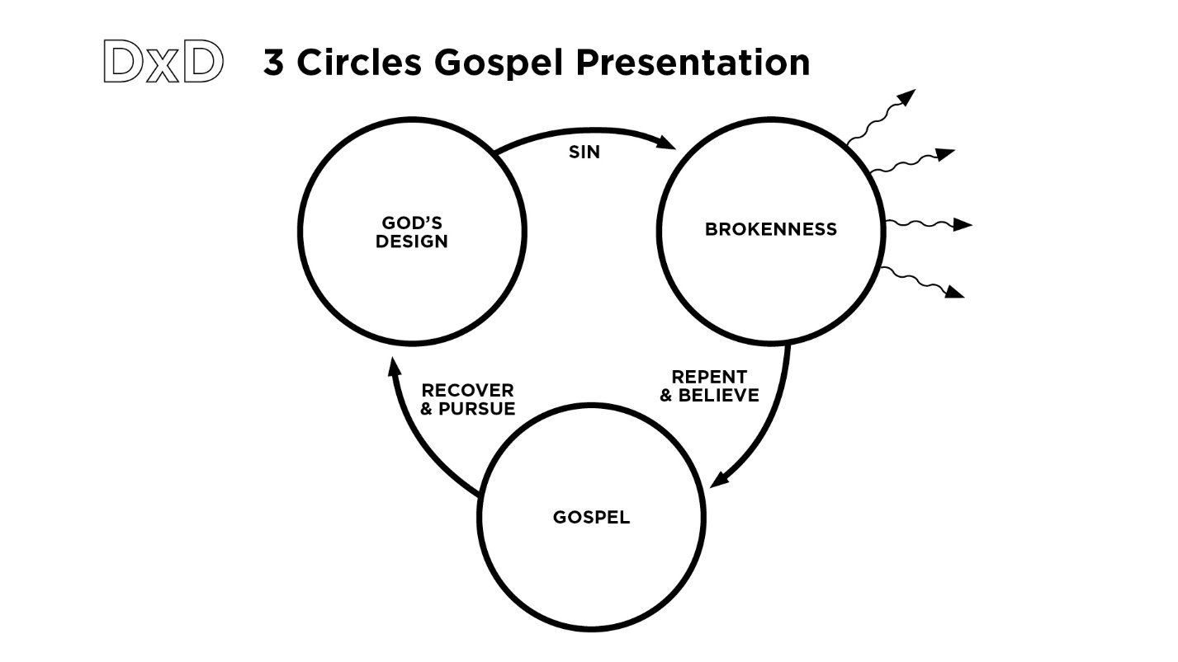
Jimmy Scroggins Videos: https://vimeo.com/showcase/6843618
How: Going
Key Concept: DxD communities serve their campuses, neighbors, and nations to engage the lost and searching with Gospel Conversations and disciplemaking while growing in their own spiritual maturity.
Key Text: Acts 1.8; Mathew 4.19-23
You will receive power when the Holy Spirit has come on you, and you will be my witnesses in Jerusalem, in all Judea and Samaria, and to the end of the earth.
. . .
Now Jesus began to go all over Galilee, teaching in their synagogues, preaching the good news of the kingdom, and healing every disease and sickness among the people.
With these two texts we learn both the where and the what of Going. We see that we are called in ever expanding distance to reach others with the Gospel: first where we are, then the surrounding area, and ultimately to those even in other countries. For us it might look something like, Gospel Conversations and Service: to your neighbors, workplace, and city; to Middle Tennessee, to overseas, non-domestic mission journeys.
The “Go” of the Great Commission introduces intentionally in all areas of our life. “Neighbors,” for example, would be a broader term than neighborhood including but not limited to one’s co-workers, friends, etc., essentially, those God providentially brings into our lives.
But what do we do as we go? Matthew wrote that Jesus taught, preached, and healed. We are to model Jesus’ approach which allows us to engage the whole person with the whole Gospel. Serving with our DxD groups is the way that we can imitate Jesus’ teaching, preaching, and healing. With the extra intentionality of serving with our apprentices, we will be able to see true multiplication occur.
Serving also allows for two other opportunities. First, we ought to always invite along the lost and searching to serve with us. Service is often an easy onramp for the unconnected. Second, combining multiple DxD groups together in service can often provide growth opportunities through a broader shared experience.

