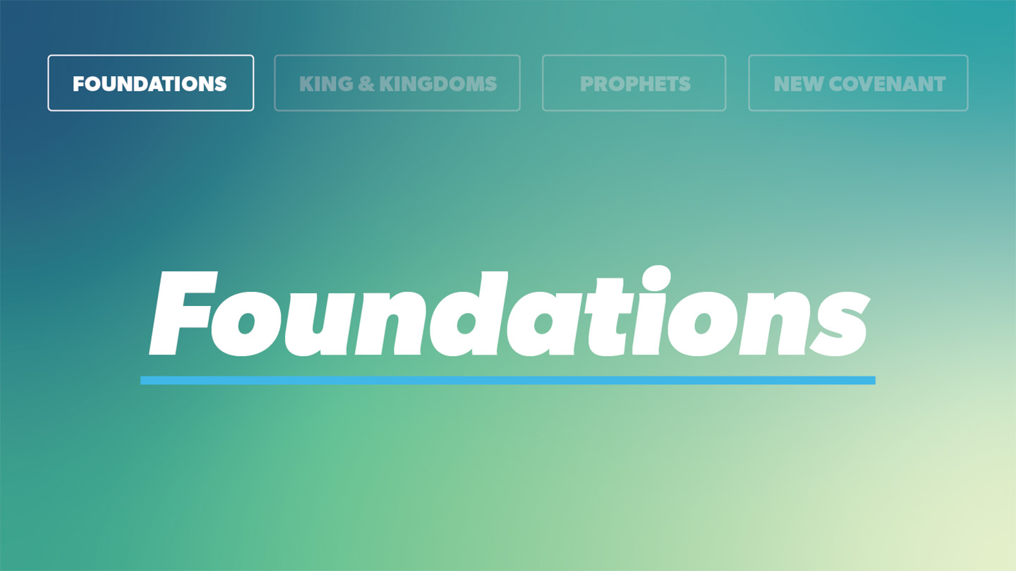

OPEN THE CONVERSATION
We’re doing something a little different this week. Say to the group: “This is important-I want you to listen and do exactly what I ask”. Then give them 5 (or more) step directions to accomplish a task (it can be anything you come up with.) Only state the request one time. Ask, what was difficult about accomplishing the task? What could you have done to make it work out better? (Pay close attention, valuing the information as important, valuing the one giving the directions, etc.)
INTRODUCTION

After four hundred years of slavery, God was preparing the children of Israel for the deliverance and freedom. He was making a people to be His human representatives in the world until He would later send His Son. It was to be a new start for them and even their calendar would change to reflect it. Share a time when you’ve experienced a completely new start. The people must have felt an incredible mix of emotions!
God had demonstrated His power over hard-hearted Pharoah and the Egyptian gods (idols) nine times, each time graciously sparing the Israelites completely from the pain and destruction caused by the plagues. This time was different. The tenth plague would be much more serious; the death of the firstborn. God would spare the Israelites again, but this time He required a response of trust and obedience from each of them in order for death to pass over their homes.

Have you ever struggled to believe salvation was as simple as the Bible claims it to be? What are some things you have tried to add to God’s recipe of salvation instead of simply accepting God’s grace?
READ EXODUS 12:1-14
- Why is it important to obey God completely, even if you don’t understand all the details or all the reasons?
- What does readiness (or attentiveness to God) have to do with obedience?
- How can you be ready to trust God without knowing where He may lead you?
- The plagues God sent exposed Egypt’s gods as idols. (see v. 12). Why do you think it was important for God to establish Himself in the hearts of the Israelites and reveal His might and character before they left Egypt?
- How is the Israelites being delivered from enslavement in Egypt a parallel picture that illustrates what happens when a person comes to faith in Christ?
WRAP UP

Put today's lesson into action: Share one new-to-you thing that you want to continue thinking about from this study.
Ask for any prayer requests, and pray for one another.
EXTENDED CUT

What’s the deal with all the blood? Scripture tells us that “the wages of sin is death” (Romans 6:23) and that for sins to be forgiven, blood must be shed (Hebrews 9:22). This concept was established in the garden of Eden when the death of an animal was required for God to make garments for Adam and Eve, once sin had entered the world and destroyed their innocence. (Genesis 3:21); God continued to teach it through the Passover and delivering the Israelites from bondage in Egypt as well as the sacrificial system that followed. Ultimately, Jesus became the sacrificial Lamb for the sins of the world.

God asked the people to be ready to go, though they didn’t know where. As we’ve seen before with Abraham, God asked him to follow in faith and trust, without knowing where He would lead. Generations and lots of offspring later, God asked His people Israel to be ready to go when He made a way. After 430 years in Egypt, no one had even a vague memory of any other place. The land promised to the descendants of Abraham, Isaac, and Jacob must have been little more than a whisper of memory as they labored generation after generation under the Egyptian sun--until Moses arrived to demand that Pharaoh let the people go. But go where? They couldn’t picture it. They didn’t know the way. But God said, “Be ready!” They would need to trust Him.

Why was it important for God to establish Himself in the hearts of the people and demonstrate His saving power to them before bringing them out of Egypt?
The Israelites had been in Egypt 430 years, since Joseph’s brothers and their elderly father, Jacob moved to Goshen while Joseph was a leader in the land. How much do you know about how and where your family lived 430 years ago? Granted, we live much more individualized lives today, where they had a distinct cultural identity and all lived together…but still, 430 years is a long time to remember and pass down faith. They were surrounded constantly by the worship and rituals of Egypt’s religious systems and cults. The way of the land was idolatry. God reacquainted His people with His power and saving care as He brought them out of Egypt. He is faithful to reveal Himself to His people through His actions, and through His Word.

Why is Passover important? Did you notice the first thing God said to Moses as He began to give instructions for the people’s deliverance in Exodus 12:1-2? He reordered the calendar of the Israelites. Moses, this event I’m preparing you for will be the start of a whole new reality.
The Passover was a significant moment for the children of Israel that is celebrated and observed to this day. Understanding all that happened when the Israelites were released from slavery and sent off to the promised land is important to understanding God’s story of redemption throughout the Bible. His timing is perfect, and there is purpose to all He does. When we trust God and obey Him, then we position ourselves to join in His redemptive story that has been revealed throughout history.

The Lord stressed that these instructions about Passover were to be followed and kept as a feast throughout generations. This was not a one-time dinner. It was a new celebratory feast that the people should make a yearly priority and everlasting ordinance. God knew that looking back on this occasion would be a powerful reminder of His power and might exercised on behalf of His people. For this first Passover, unleavened bread was a practical necessity due to the expediency with which the people would need to exit Egypt. In all the following Passover feasts and celebrations, unleavened bread would serve as a testimony of the Lord’s protection and provision. This is the commemorative meal Jesus and His disciples were eating centuries later, the night before His crucifixion when He blessed the unleavened bread they were eating, saying “This is my body, broken for you.” The next day He gave His blood for us as the once and for all Lamb of God.

Passover is full of pictures and themes that occur throughout God’s Word. For example, leaven (the yeast in bread) is also symbolic of sin and corruption in the Bible. In Galatians 5:9, Paul compared the way a little leaven influences an entire batch of dough to the way any amount of corruption infiltrates the Christian life. Just as leaven causes dough to puff up, sin causes a person to be puffed up. Just as the Passover required unleavened bread, we must guard against allowing sin into our lives in even the smallest amount because it can affect every part negatively. The Lord calls us to moral purity. Any time we think sin doesn’t really matter or make a difference, we can remember how leaven affects all the dough and make the choice to live an “unleavened” or godly life. We reflect on this when we eat the Lord’s Supper together today.

God was forming a people for His glory, fulfilling the promises he made to Abraham, Isaac, and Jacob. God had promised descendants beyond counting, a land, and a lineage. The Passover was a pivotal moment in the development of Israel as a people. God showed Himself faithful to them, renewed their faith with fresh encounters with Him through Moses, and presented them with a choice at Passover to trust Him enough to obey Him by placing blood on their doorposts. He led them, and they followed.

Response to God was a crucial part of Passover. The people’s first response to God’s instruction was worship. They honored the Lord and were grateful for all He said He would do. This is one of the most important parts of the Passover story because it reminds us of the truth that to receive the good things God had for them, the people had to choose obedience. Their deliverance hinged on their response to the truth God revealed to them.

