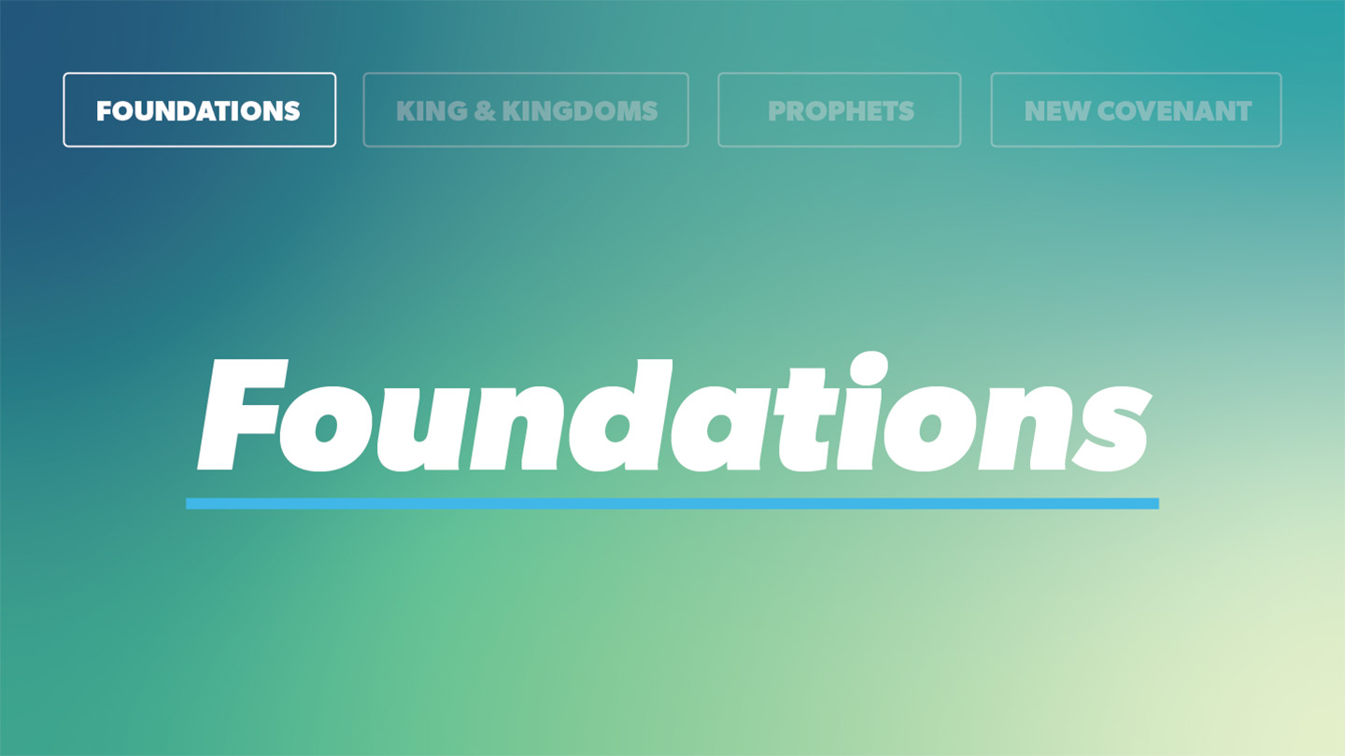

OPEN THE CONVERSATION
Take some time to build relationships with the students:
- Ask for each student’s high and low from the week.
- Today’s RBQ (Relationship Building Question): You have to choose one: Cake or Ice Cream?
INTRODUCTION
Have you heard of the phrase “a fork in the road?” No, it’s not a literally utensil just chilling in the road. Perhaps you’ve read the famous poem by Robert Frost, “The Road Not Taken.” In it, Frost describes a “fork” in the road in the woods where he is presented with two different roads to take, each going in a different direction. Each of us has had many “fork in the road” type moments in life. Maybe you have been hiking and come to a fork in the road and must choose the path to take. We all make such decisions, each with varying degrees of importance. Deciding what classes to take, what activities to be involved in, what friends to have, or even what food to eat at lunch are all “fork in the road” type moments. Today’s lesson centers on the ultimate choice we must make; whether to follow Jesus and love the Lord with our whole heart. Each day we are presented with opportunities to follow Christ and obey his commands or to turn away from Him. God is inviting you to obey his commands and pursue a life found in Jesus.
In today’s passage, Moses is teaching a new generation of Israelites the importance of following God’s commands as they are about to enter the promised land.
What is a recent “fork in the road” type of decision you had to make? How did you come to your decision?
READ DEUTERONOMY 30:1-6
- How does knowing God is a God of compassion impact your desire to follow him and obey his commands?
- What does it look like to love God with all of your heart, mind, soul, and strength?
READ DEUTERONOMY 30:7-14
- How has God blessed you when you have obeyed him?
READ DEUTERONOMY 30:15-20
- What are some false gods in your life you need to walk away from?
- How can you as a group support one other in pursuing life found in Jesus?
WRAP UP

Put today's lesson into action: How can you apply today’s lesson to your life this week?

Ask for any prayer requests and pray for one another.

EXTENDED CUT

The book of Deuteronomy is the final book of the Pentateuch. It constitutes Moses’ last words to Israel before his death. In it, Moses preaches a series of sermons to the people of Israel, calling for covenant obedience. Moses is speaking to a new generation of Israelites as the entire generation that initially received the covenant at Mount Sinai has died in the wilderness. The last of his previous generation, Moses seeks to encourage the new generation to rightly interpret the law and follow God’s commands. Moses begins Deuteronomy by recounting all that the Israelites have experienced up to this point, including the previous generation’s lack of obedience to God and his covenant. He also teaches the law and the importance of following the Lord, all while applying the commandments to the context of Canaan where they will soon be. The heart of Deuteronomy lies in the familiar passage of Deut. 6:4-9, known as the Shema. Here Moses commands Israel to, “Love the Lord your God with all your heart and with all your soul and with all your strength.” The passage for today takes places in Moses’ third sermon. In it, God renews his covenant with the people of Israel at Moab, where they are camped out before they enter the promised land. The covenant is a revision of the Sinai covenant, incorporating the Sinai covenant while also looking ahead to future generations (Deut. 29). In the passage today, Moses challenges Israel to keep the covenant, asking them to choose life. Following the Lord results in blessings while disobeying Him results in consequences. Thankfully today, although we are sinners who fail to keep God’s commands, we can decide to choose life by loving the Lord our God and following Jesus Christ.

1. How does knowing God is a God of compassion impact your desire to follow him and obey his commands?
While Moses is encouraging the people of Israel to obey God’s commands, he also knows they will fail at times. This isn’t the end of the story, however, as God will have compassion for his people and offer a path of restoration (Deut. 30:3-4). If the people obey God and love him with “all their heart and soul,” God will bring them back to the promised land. Moses anticipates Israel’s rebellion against God yet offers them the grace of God. The same God that remained faithful to his people in Israel is the same God that remains faithful to us. When we mess up, God does not banish us. When we ask for forgiveness and seek to love the Lord with all of our life, God is there to receive us.
2. What does it look like to love God with all of your heart, soul, mind, and strength?
In Matthew 22:37, Jesus echoes Deuteronomy when giving the greatest commandment. “‘Love the Lord your God with all your heart and with all your soul and with all your mind.” Jesus is the One who loved God perfectly with all of his being. In John 15:10, Jesus says if you keep his commandments you will abide in his love. So how do we love God? We keep his commandments. To love is not to be reduced to a sentiment or feeling. While we are called to love God and desire him, we are also called to love him with our entire being. Our actions reflect what we love. Are we setting our minds on the “things above” (Col. 3:2) or on worldly things? Are we seeking Godly desires of our hearts or earthly pleasures? Are we persevering in the face of difficulty? We when love God with our whole being, we love Him, are satisfied in Him, and seek to obey his commands.
3. How has God blessed you when you have obeyed him?
In verse 9, Moses lists the blessings and prosperity that would come when one obeys God. God was committed to the welfare and good of those who loved him. God is also committed to our good. He knows what is best for us. Sometimes following God requires us to do things we don’t want to do though. Maybe you wanted to sleep in this morning instead of coming to church. A blessing from obeying God and coming to church is the fellowship with other believers. While that is a simple (but truthful) example, we can all think of ways God has blessed us when we decide to follow him. By remaining in his Word and seeking guidance through prayer with Him, we can continue to seek his will in every aspect of our lives.
4.What are some false gods in your life you need to walk away from?
The people of Israel had to decide whether they were going to wholeheartedly love God and turn away from other, false gods or not. While we may not have false gods or idols similar to the people in ancient times, false gods still exist today. Money, success, power, politics. the approval of others, dating, etc. We can make anything an idol, a false god we give our life to rather than God, the Creator of the Heavens and the Earth. Each one of us has things in our life we make idols of. God is giving us the opportunity to choose life over death. If we live for the things of this world, we will be living in sin apart from God and ultimately not be living the abundant life found in Jesus.
5. How can you as a group support one other in pursuing life found in Jesus?
In Deuteronomy, Moses was speaking to all of Israel. They were all receiving the same message to obey God’s commands. While each individual person was called to obey God, Israel as a whole was as well. Each one of us is called to love Jesus and live in relationship with Him. Like the people of Israel, we don’t live in isolation. We are part of a community with friends and family we are called to love and encourage. If a friend is struggling to follow Christ, be a friend and talk to them, pray with and for them. As a group, seek to get to know one another better and do life together. Be there for one another. Share in each other’s joys and struggles. Show love to one another and be there for each other. It may not be easy but encouraging others to pursue a life with Jesus is the best thing you can do as a friend for them.

