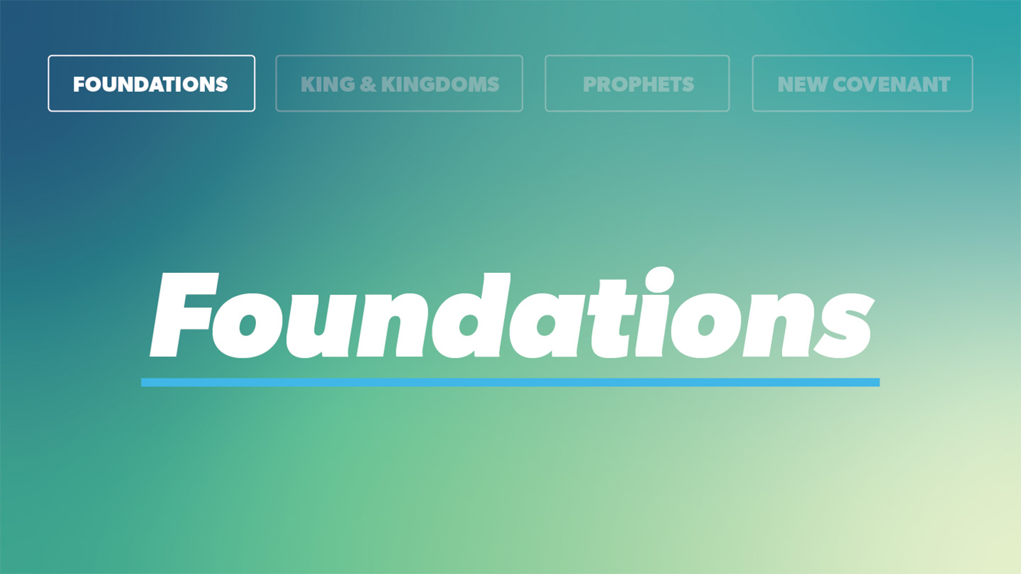

OPEN THE CONVERSATION
Take some time to build relationships with the students:
- Ask for each student’s high and low from the week.
- Today’s RBQ (Relationship Building Question): When you were younger, what did you want to be when you grew up?
INTRODUCTION
When you were a child. what did you want to be when you grew up? Perhaps you wanted to be a doctor, an astronaut, or a professional athlete. We all have dreams and aspirations. Think about your plans and goals today. It could be related to school, a relationship, a career path, or a hobby. Do these goals honor the Lord? That’s great if they do! More importantly though, have you considered God’s plans for you? Rather than simply trying to please God, we are called to allow God to order our steps. In the lesson today, David has an idea he thinks will glorify God. After establishing Jerusalem as the capital of Israel, David wants to establish a permanent dwelling place for God. When looking around at his beautiful home, it bothered David that the ark of the covenant, the presence of God, was still housed in a tent. Despite his good intentions, David failed to consider what God wanted. As we will see, God doesn’t simply reject David’s plan; He responds with an ever greater one. Like David, we can always trust in the Lord and know that his plans are better than ours. While David was only thinking about his specific time and place, God was thinking about his plans for eternity and how he would establish his kingdom through his Son, Jesus Christ.
READ 2 Samuel 7:1-7
- Can you relate to David? When have you seen in your life that a good thing meant to honor God may not actually be in God’s plans?
READ 2 Samuel 7:8-11
- God recalls all he has done for David and the people of Israel. Why do you think it’s important to remember what God has previously done in your life?
- Where in your life is God currently calling you to trust Him?
READ 2 Samuel 7:12-17, 28-29
- How does God’s plans for David surpass David’s for God? Why should we care?
- How will you be more intentional about submitting to God’s plan for your life?
WRAP UP

Put today's lesson into action: How can you apply it to your life?
Ask for any prayer requests and pray for one another.

EXTENDED CUT

While Samuel is not explicitly mentioned in 2 Samuel, he stills looms over the book as a key figure in the story. A key reason Samuel is not mentioned in 2 Samuel is that the books of 1 and 2 Samuel were originally one book. Samuel, the final judge for Israel, anoints Saul and then David as the first kings of Israel. Samuel helps God establish Kingship in Israel. After Saul failed to obey the Lord as king, God raises David, a man after his own heart (1 Sam. 13:14). Saul anoints David and the Spirit of the Lord comes upon David (1 Sam. 16:13).

2 Samuel begins with David mourning the death of Saul. Despite Saul trying to murder him, David laments the loss of Saul. After a war between the house of David and the house of Saul, David is anointed King over all of Israel (2 Sam. 5:3-4). As King, David conquers Jerusalem and establishes it as Israel’s capital. While Jerusalem is the political capital of Israel, David seeks to make it Israel’s religious capital as well. In addition to moving the Ark of Covenant moved into the city, David desires to build a permanent temple before God rather than a tent. God reminds David of all he has done for His people, traveling with them out of Egypt and defeating Israel’s enemies. Rather than granting David’s desire of a permanent dwelling place, God has something far greater in mind. In 2 Samuel 7, God promises that a Davidic king, a descendant of David, would reign over the people of Israel. Through this Davidic Covenant, God establishes a royal house. This is a fulfillment of prophecy as God alludes to the future promise of a king in his covenant with Abraham (Gen. 17:6) and in his covenant with Moses (Deut. 17: 14-15). Jacob also promises Judah that the scepter, the symbol of kingly rule. Will not depart from the tribe of Judah (Gen. 49:10). It is from the Davidic line, that God will build a temple and more importantly, establish his kingdom forever (2 Sam. 7: 12-13).

1. Can you relate to David? When have you seen in your life that a good thing meant to honor God may not actually be in God’s plans?
At first glance, David’s plan was noble. He was trying to serve God. We can all relate to times where we are seeking to serve God. In our busy lives, however, there are certainly times where we want to serve God, but we don’t pause to pray and seek God’s guidance. Seeking to honor God with our plans is a at first glance a good thing. We must remember though that we are to follow God’s plans, not ours. Proverbs 3:5-6 says, “ Trust in the Lord with all your heart and lean not on your own understanding; in all your ways submit to him, and he will make your paths straight.” We don’t need to worry about bringing God into our plans. God will guide our paths.
2. God recalls all he has done for David and the people of Israel. Why do you think it’s important to remember what God has previously done in your life?
God doesn’t simply reject David’s plan and move on. He reminds David of all the good he has done for him. David can trust that God has his best interest in mind because 1. He is God and 2. He has protected David throughout David’s life. In those times your plans don’t align with God’s, remember all that God has done for you. You can trust God. His plans for you are greater than our own. The God that created the heavens and the earth and sent his Son, Jesus Christ, to die on our behalf is a trustworthy and loving God.
3. Where in your life is God currently calling you to trust Him?
Are you currently pursuing something that God has called you to? Maybe you’ve felt God leading you towards something that you have been ignoring or even running from. God calls us to trust him. While it’s easy to compartmentalize our lives between church and school, God has plans for our entire life. He wants us to live for Him every day of the week.
4. How does God’s plans for David surpass David’s for God? Why should we care?
David was thinking of a physical house for the tabernacle. God’s plans far surpassed David’s as they went beyond David’s specific time and place. God promises David a royal house. It is in this Davidic Covenant that God promises that a descendant of David, would reign over the people of Israel. It is from the Davidic line, that God will ultimately build a temple (Solomon). Most importantly, God promises to establish his kingdom forever. We now know that God establishes his kingdom through Jesus Christ. God’s promises of a Messiah who establishes his kingdom forever his fulfilled in Christ. And we should care because God was so gracious to include us in his plans! When we accept Jesus Christ as our Lord and Savior, we are part of the family of God with a place in his kingdom.
5. How will you be more intentional about submitting to God’s plan for your life?
It’s not wrong to have plans, goals, or dreams. When you have such plans, consider what God has to say about them. Pray for wisdom and discernment. Pray that God, through his Word and the Holy Spirit, will make His plans clear to you. Talk to trusted followers of Jesus whether that be family, friends, or church leaders. Continue to live in God’s Word each day and spend time with God in prayer, and you will find it easier and easier to rely upon God when considering what God has planned for you.

