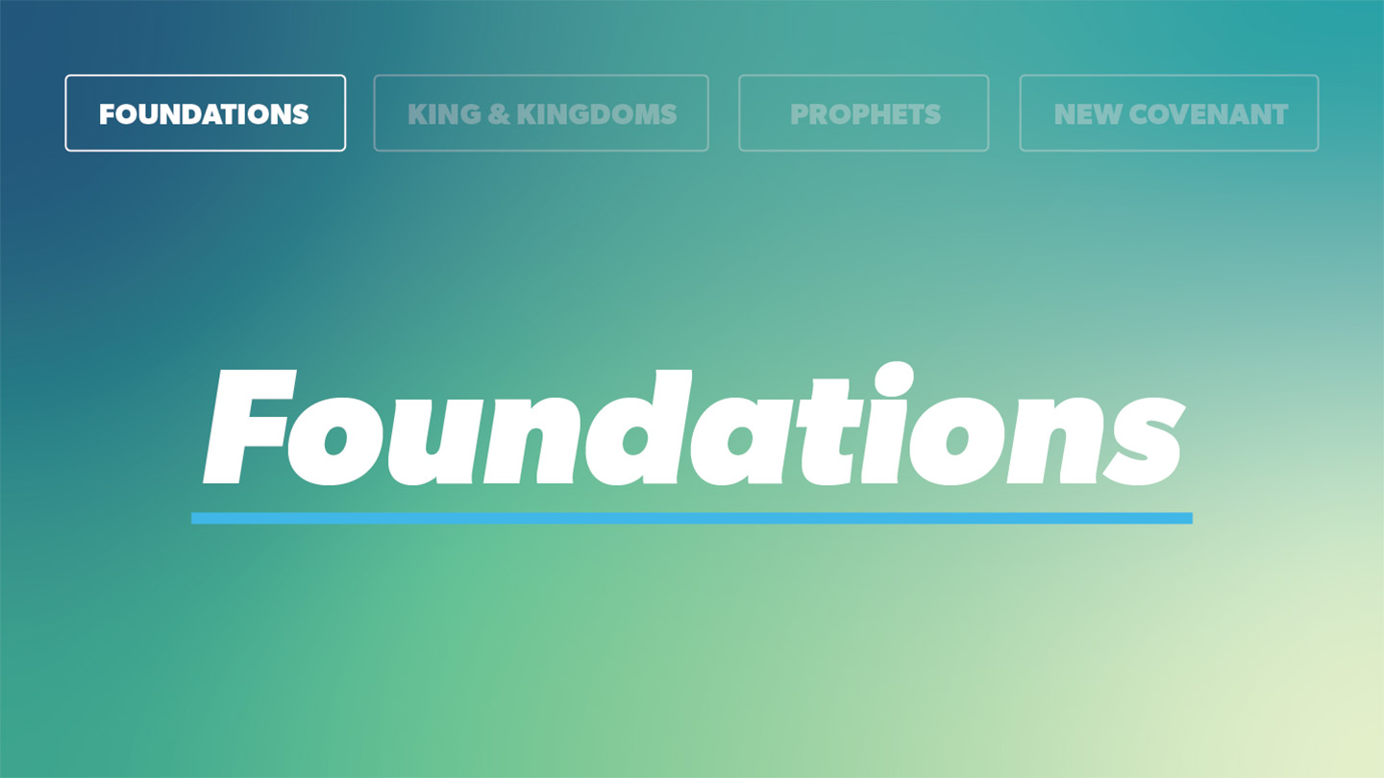

OPEN THE CONVERSATION
Take some time to build relationships with the students:
- Ask for each student’s high and low from the week.
- Today’s RBQ (Relationship Building Question): How much would someone have to pay you to eat an entire jar of mayonnaise in one sitting.
INTRODUCTION

Think, what is the most valuable thing you own? What would you be the saddest to lose? Now... if you lost that thing, what would you be willing to do to get it back? When something important is lost, most people will do extreme things to find it again. A person may take apart the plumbing under a sink if a ring accidentally goes down the drain. People will stick their hands in a toilet to recover their phone they just accidentally dropped it in the gross water. When you have lost something that means a lot to you, you will do whatever it takes to regain it. Today we are studying what David was willing to do to regain something very important that he lost due to sin in his life.

What is the craziest thing you’ve ever done to retrieve something of value that was lost?
READ PSALM 51:10-13,16-17
- When have you felt like David and needed the Lord to do something in your life only He could do?
- What is the difference between seeking an improved heart and a completely new one? Why is it necessary that our hearts be new?
- What has been causing distance your relationship with the Lord? How do you need to address this and seek God?
- Where are you tempted to rely on your own power and wisdom over God’s?
- How can you use your own influence to point others to a right relationship with the Lord?
- Where do you need to seek restoration with God today? Where do you need to display humility and contrition?
- Where do you need to confess your sin openly before God with a humble and contrite heart?

WRAP UP
Put today's lesson into action: How can you apply it to your life?
Ask for any prayer requests, and pray for one another.
EXTENDED CUT
Everyone sins and all sin breaks our fellowship with God. The way we respond when we sin is a big deal and has far reaching effects in our lives. David experienced the spiritual weight that accompanies unconfessed sin until he couldn’t take it and cried out to God for restoration. In this moment, David recognized that only God could bring the restoration He needed. When we surrender our lives to the Lord, we become new creations and experience the miraculous transformation that follows, but we must still stay vigilant about our spiritual condition. Psalm 51 teaches us the importance of our heart’s attitude when seeking to be cleansed and restored into a right relationship with the Lord. David specified that while animal sacrifice had its place in his day, a humble and contrite spirit matters more to God.
READ PSALM 51:10-11
King David experienced the agony of realizing his own sin and how far he could fall away from the Lord. David poured out his heart to the Lord as he acknowledged the great mercy the Lord bestows on those who humble their hearts in repentance. This psalm is familiar and dear to many likely because of the way we can relate to being confronted with our own sinful nature, spiritual failings, and need for restoration. We can learn from the way David approached the Lord as he sought restoration and redemption. David wasn’t just looking to have his heart cleaned up, but he wanted it to be transformed to the extent that it seemed new compared to the previous state. He wasn’t just after a whitewash job on his old one but felt the need to have a completely new heart from God. The word create in Hebrew is bara, which is the same word used in describing creation in Genesis and references something that can only be accomplished by the Lord.
When have you felt like David and needed the Lord to do something in your life only He could do?
Only God can give someone a new heart. David acknowledged that, even as a powerful king, he couldn’t do anything to truly transform his heart. This was for David, and still is, only something that happens by the power of God. All who place their faith in Jesus will become new creations and be given new hearts.
What is the difference between seeking an improved heart and a completely new one? Why is it necessary that our hearts be new?
David further expressed his desire for a right spirit. He knew the value in being prepared to stand against a persistent enemy and wanted to live in constant faithfulness to the Lord. This portion of David’s prayer was an indication of humility as he declared his dependence on the Lord. This man who was rich, powerful, and influential boldly confessed how much he needed the Lord to live in godliness. David also begged to remain in God’s presence. He knew having God’s presence in His life was a blessing and privilege, and in the past, sinful leaders had the presence of the Lord removed. David did not want that to be his fate. His desire was to have his relationship renewed with God though it had been broken by his willful sin. It wasn’t enough for David to have his heart cleansed if God remained distant. He wanted both cleansing and a close relationship.
What has been causing distance your relationship with the Lord? How do you need to address this and seek God?
READ PSALM 51:12-3
Over a period of living with unconfessed sin, David experienced the misery of a broken relationship with the Lord. He recognized the struggle of spiritual defeat that accompanies separation from the Lord. Think about times when you have been in a similar situation. Although we often cling to our sin and desire to make our own choices, when we choose to live outside the will of God in our own strength, things become dire in a hurry. David acknowledged he had lost the joy of his salvation and the way to get it back was by drawing near to God. When you fall away from living in the joy that comes from being rescued from your sin and brought into fellowship with God, it is important to go back to the source of the joy: God. David mentioned the Lord’s willingness or generosity in his request. This expressed David’s confidence in the Lord as well as his own limitations to gain what he needed apart from the Lord. When people believe they have the answers or the power to make their own choices that lead to life, it sets them up to fall into sin just as David did in the situation that led to this psalm of restoration.
Where are you tempted to rely on your own power and wisdom over God’s?
David’s own dark days were an obstacle to his teaching others what it meant to rely on and trust the Lord. To be most effective in the things God has called us to do, it is crucial that we first be in right relationship with Him. As is often said, we cannot give away what we do not have ourselves. David recognized the privilege and responsibility of pointing others to the truth about God. It is possible that after living in his own despair and spiritual defeat, David was even more motivated to bring the people into the freedom and joy of a relationship with the Lord. He wanted to be restored, and he wanted others to experienced restoration also.
How can you use your own influence to point others to a right relationship with the Lord?
READ PSALM 51:16-17
The practice of offering sacrifices would have been foremost in David’s mind when reflecting on his own sin and how to be restored. In these verses, he was not taking sacrifice lightly but stated clearly that God’s greatest concern is our posture of heart and spirit. In these verses, David made it clear that he was willing to do whatever God desired most. Coming to this point displays true humility and sincerity of heart in submission to God. David’s words also remind us that someone can offer physical sacrifices without a broken spirit and contrite heart. Think about how you have seen this to be true in your life. It is easier sometimes to do the right thing outwardly while avoiding the hard work of seeking a renewed heart. It is possible David offered numerous required sacrifices over the past few months in a desire to absolve his sins and was admitting the emptiness of those actions. When we do something for the Lord without the proper spirit and motivation, does it really make any difference? David had learned the value of the condition of his heart and spirit over his actions.
Throughout his life, David demonstrated a focus on pleasing God over others. This served him well in this instance as he recognized the need for a broken and contrite spirit. The specific sinful behavior David repented of might have been normal for other kings in the time (2 Samuel 11). However, no matter the views of others, God made it clear to David that he had sinned and needed restoration. As this was brought to light in David’s life (2 Samuel 12), he knew only God could give the restoration He needed.
Where do you need to seek restoration with God today? Where do you need to display humility and contrition?
David had committed a grievous sin and lived for months without repenting. During those days, he experienced the feelings of bleakness and spiritual defeat that follow sinful behavior for believers. David wrote Psalm 51 as a plea to be restored and cleansed from his sin, and it gives us an example to follow when we face similar consequences for our own sin. Not only do we need to recognize our sin as David did, but we also need to ask for the same things he requested from the Lord. When we recognize our need for salvation and place our faith in Jesus, we are made new creations. When sin separates us from God, we should seek to be restored to the joy of our salvation and not continue to live in defeat. David acknowledged his need for God to do the restoration work. This need is the same for us, and we should be quick to see that we need to depend on God for righteous living as well as for restoration when we sin. Evidence of our dependence of the Lord will be displayed in our hearts and spirits. David proclaimed that God will not despise a broken and contrite heart. As we reach this point, we find God ready and willing to restore and forgive.

Where do you need to confess your sin openly before God with a humble and contrite heart?

How can we as a group encourage and support one another in approaching God in this way on an ongoing basis?

