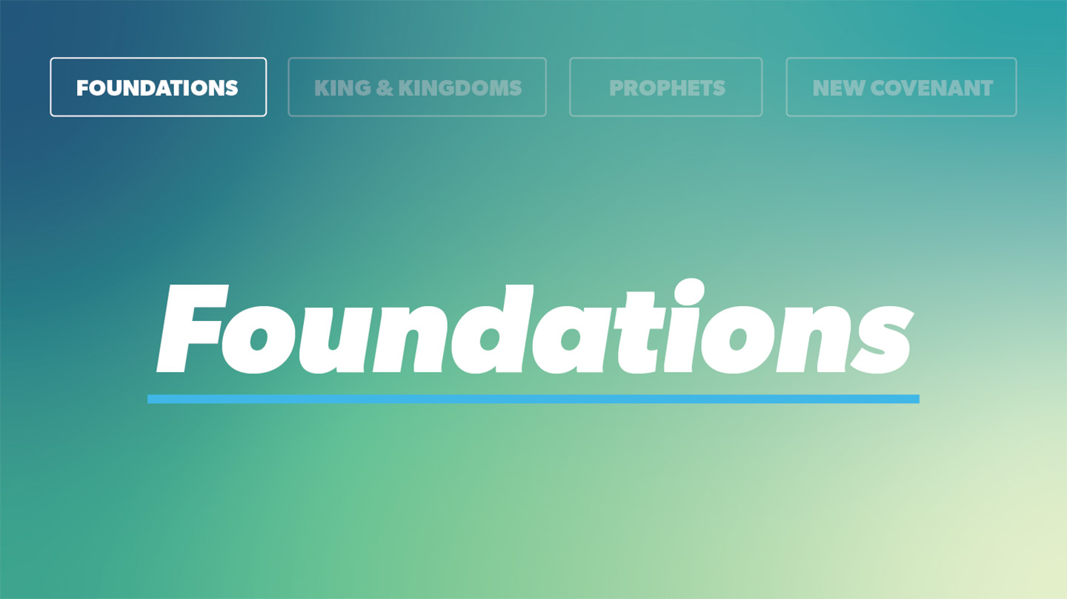

OPEN THE CONVERSATION
Take some time to build relationships with the students:
- Ask for each student’s high and low from the week.
- You can only choose one place to go for the rest of the summer: Beach or Mountains?
INTRODUCTION
Do you have a place that has really strong memories tied to it? Maybe it’s the bedroom you grew up in. Maybe it’s the football field where you won a big game. Maybe it’s a concert venue where you saw your favorite band. Each of us has a handful of places that hold really deep happy memories. And any time we go visit those places, we’re immediately taken back to those mountaintop moments.
But the opposite is also true: sometimes, when we feel really low, we think we have to go back to that place to get on top the mountain again. We think if I can just feel like I did then, everything will be great. Those mountaintop moments are amazing, but you can’t always live on the mountains. We have to come down eventually and live in the ordinary. The beauty of what Solomon discovered in our passage today is that God promises to dwell not just in the mountaintops, but in every moment with his people.
READ 1 Kings 6:11-13
- Do you think it’s possible to do the right thing with the wrong heart? Why or why not?
- God gave very specific details for how the people should make the temple, but here God reminds Solomon that the state of their hearts is where the work really starts. How does the posture of our heart toward God affect our actions?
- How can you intentionally develop both the right heart and the right actions?
READ 1 Kings 8:24-30
- Have you ever felt God was leading you to do something but were discouraged by the obstacles in your way?
- Where are you prone to think God might be stopped by obstacles too?
- What would be different if you really knew that God promised no obstacle can keep him from hearing you, watching your life, and working for your good?

WRAP UP

Put today's lesson into action: Where is God asking you to step out in faith this week, even if there are obstacles?
Ask for any prayer requests and pray for one another.

EXTENDED CUT

With the craziness of the world around us, sometimes we can wonder if God Is really paying attention to everything happening. Does he see the details? Does he hear our prayers? Solomon’s story reminds us that God is always present—and always ready to work for his people. God had a plan for the temple down to the centimeter. He thought through every square inch of that temple and gave the whole plan to Solomon. But that wasn’t the most important part: the most important part was that Solomon understood this meant God loved him, heard his prayers, was watching over him, and was always ready to work on his behalf. That gave Solomon the confidence to step boldly after God, if he would only watch for his heart.
1. Do you think it’s possible to do the right thing with the wrong heart? Why or why not?
God gave Solomon very specific instructions for the temple. Every small detail was planned out, and God expected Solomon to do it all. But, here in these verses, we see God remind Solomon what ultimately matters isn’t mindless obedience to his instructions. What ultimately matters is the posture of your heart. Someone can do all the right things, but with all the wrong intentions, and it’s as if they never really obeyed.
2 God gave very specific details for how the people should make the temple, but here God reminds Solomon that the state of their hearts is where the work really starts. How does the posture of our heart toward God affect our actions?
When we follow God from a heart of love and obedience, we are drawn closer to God. The benefits of following God—peace, joy, love, life, wisdom—start showing up in our lives and we start looking more like Him. It’s like we’ve stepped into the promises of God.
But when we follow God’s instruction without any concern for him, we end up frustrated. We can’t figure out why we’re not getting anything out of it, why nothing is changing. But it’s because the point of obedience is to draw you closer to God, and the benefits of obedience only start showing up when your heart takes you closer to God.
3. How can you intentionally develop both the right heart and the right actions?
There are lots of simple things we can do to line up our hearts and our actions, but the heart of all of them is this: spend time with God. Be with him. Whether you’re praying, reading your Bible, trying to model him to the people around you at school, asking him for help in your daily life, going to church—wherever you might be, whatever you might be doing, the trick is to make being with God the goal.
4. Have you ever felt God was leading you to do something but were discouraged by the obstacles in your way?
We all face obstacles in obeying God. That’s part of what grows our faith. But we can take heart knowing God is present with us—and he can’t be stopped.
5. Where are you prone to think God might be stopped by obstacles too?
Maybe you have a hard time believing God can give you more than he’s asking you to give up. For example, maybe you know God is calling you to stop listening to a certain type of music, because it doesn’t glorify him. But you’re afraid you’ll lose friends if you do, because it’s a big part of your connection with them. And you aren’t positive that God can or will overcome that obstacle, so you don’t step out in faith.
6. What would be different if you really knew that God promised no obstacle can keep him from hearing you, watching your life, and working for your good?
We all would have more confidence in stepping out in faith if we were totally positive God keeps his promises. But that’s exactly what this story is telling us. God kept his promises to David, he’s keeping them to Solomon, and he vows to keep them to us too. Everything he did for them, he can do for us—but we’ll never know until we step out.

