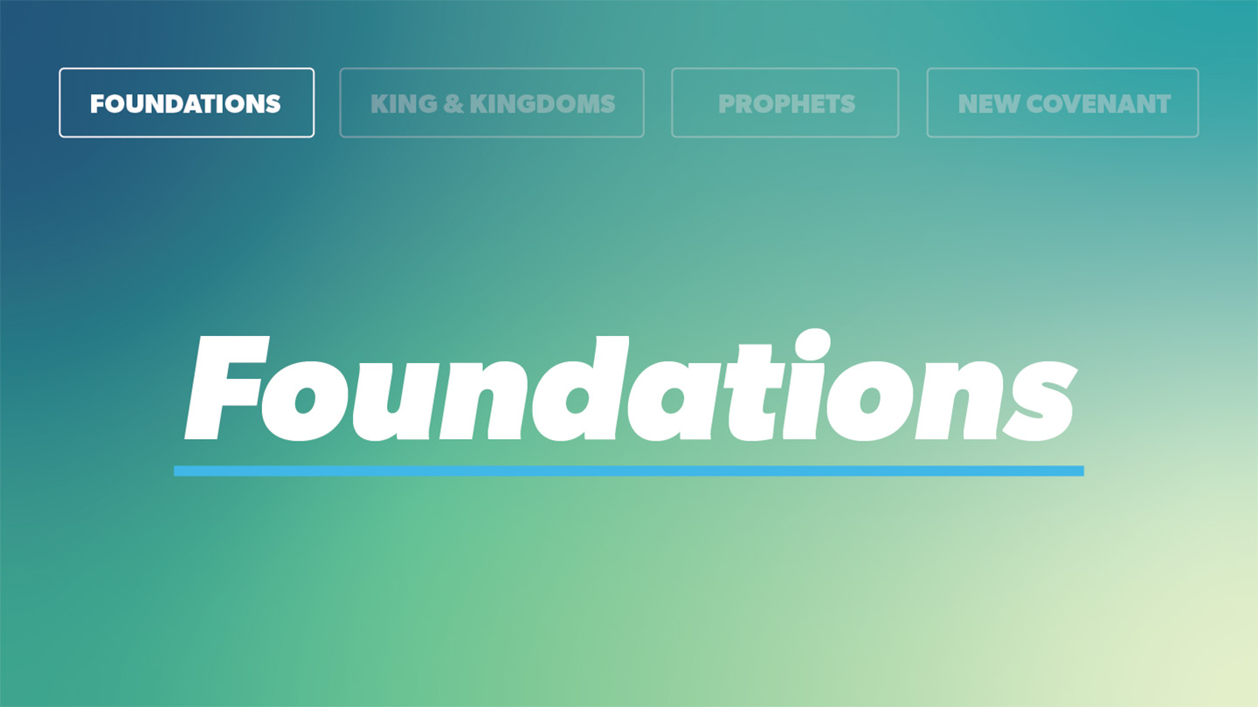

OPEN THE CONVERSATION
Take some time to build relationships with the students:
- Ask for each student’s high and low from the week.
- You can only choose one place to go for the rest of the summer: Beach or Mountains?
INTRODUCTION
This may be too old of a reference for you but the band U2 released a famous song in the eighties titled, “I Still Haven't Found What I'm Looking For.” Throughout the song, the narrator searches for meaning in all the wrong places. While coming up short, the chorus repeats with the refrain, “But I still haven't found what I'm looking for.” The song points to the reality that, within each one our hearts, lies a deep desire to discover the ultimate meaning of life. We are all yearning for transcendence. Such a desire isn’t anything new. Humans across thousands of years have sought the meaning of life. Told through the eyes of Solomon who refers to himself as the Teacher, the Book of Ecclesiastes centers on the quest for life’s greater meaning.
Through its narrative told by the Teacher, Solomon, Ecclesiastes examines how to find meaning and truth. Because we live in fallen world, nothing in the world will truly satisfy us. To find true wisdom and meaning, we must turn to God. When we trust in Jesus and give him our lives, we are ensuring a life full of meaning that provides hope beyond even death.
READ Ecclesiastes 1:12-18
- In 1 Kings 3, out of all the things he could ask the Lord for, Solomon asks for wisdom. What do you want to ask God for right now?
- Solomon has seen “all the things that are done under the sun” and found they do not satisfy his desire for meaning in life. Where in life have you looked to the world for meaning and affirmation?
READ Ecclesiastes 12:9-14
- Verse 11 describes wise words as providing strength and guidance. Do your words reflect the wisdom of God?
- How does us holding a right view of God being the source of our meaning in life affect how we live each day? Does it strengthen your desire to live for Jesus?

WRAP UP

Put today's lesson into action: How can you apply it to your life?
Ask for any prayer requests and pray for one another.

EXTENDED CUT

Following Proverbs, Ecclesiastes continues the theme of wisdom. The central question in Ecclesiastes is whether life is meaningful and if so, from where does life derive its meaning? Ecclesiastes is named after its central character, translated as “Teacher.” The Teacher, Solomon, embarks on a journey to discover the meaning of life. Throughout the book, Solomon shares what he has learned. Solomon initially looks for meaning in worldly things, ultimately realizing that in a broken world, nothing has meaning apart from God. Throughout Ecclesiastes, Solomon looks in all the wrong places for meaning. Laughter, work, possessions, money, earthly relationships. None of these satisfied his soul. Ultimately, Solomon concludes Ecclesiastes by recognizing that all life is a gift from God and that God is the source of life’s meaning. Just like Solomon, we should recognize that God gives life meaning and in response to this, seek to live for Him. By giving our lives to Christ and trusting in Him, we can honor God and live a life worthy of Him.
1. In 1 Kings 3, out of all the things he could ask the Lord for, Solomon asks for wisdom. What do you want to ask God for right now?
As seen in 1 Kings 3 and in Ecclesiastes today, Solomon is constantly consumed with wisdom. He is looking for wisdom and meaning to life’s greatest questions and he knows his search is futile without God. The type of wisdom Solomon seeks can only come from God. What do you need from God today? Are you struggling with similar existential questions about the meaning of life and why we are here? Do you need wisdom about a specific situation? Do you need the peace and comfort that only God can provide? Through Jesus Christ, we can directly ask God to provide for our needs. And God always meets us where we are. True wisdom can be found by being fully dependent on God.
2. Solomon has seen “all the things that are done under the sun” and found they do not satisfy his desire for meaning in life. Where in life have you looked to the world for meaning and affirmation?
Solomon’s view from “under the sun” (v. 14) was limited. His perspective was limited to the world that he knew. Solomon was looking for meaning in worldly things with a worldly view. Only God sees all and knows all. With our limited perspectives, we sometimes may look to the world for meaning. We wrongly turn to friends, worldly success (school, work, athletics, etc.), money hoping they will fully satisfy our needs. In this passage, Solomon is frustrated because he can’t find the answer to his longing on his own. Similarly, if we look to the things of this world on their own for meaning, we will be disappointed. Trying to grasp true meaning in life without the Lord is like chasing after the wind (v.14). Only God can satisfy our needs. True wisdom and meaning can only be found in the Lord. Everything in the world – our hobbies, entertainment, work, relationships – should all point us to God.
3. Verse 11 describes wise words as providing strength and guidance. Do your words reflect the wisdom of God?
The words that we speak reveal a lot about what is influencing us. Matthew 12:34 says, “…For the mouth speaks from the overflow of the heart.” Are our words guided by the Holy Spirit, being in the Word, spending time in prayer? Or are they influenced by something else? As followers of Christ, we are called to be like Christ with our whole selves including our words. Do our words build up others or tear them down? Do they continually point to the unfailing love and hope we have in Jesus, or do we only add to the chaos and negativity of this world? God, the source of all wisdom, can help us when we aren’t sure of what to say. The Holy Spirit lives inside of each believer and offers counsel. We can turn to Scripture for wisdom.
4. How does us holding a right view of God being the source of our meaning in life affect how we live each day? Does it strengthen your desire to live for Jesus?
The only way to find meaning and significance in life is through the Lord. The most important decision we make in life is not who we will marry or what career we work in; it is whether we give our lives to Jesus Christ as our Lord and Savior. God has created us to be in right relationship with Him through his son Jesus and to share his love with the world. When we hold this view of the world, everything else is influenced by that. The words we say, the things we do all should point to the Creator of all things. When we have a proper fear and reverence of God (v. 13), we desire to obey his commands. By remembering why we are here, we can hold on to the hope found in Jesus regardless of what comes our way. Additionally, things of this world such as our relationships, activities, career, can be rightly enjoyed when we view them through the lens of Christ rather than attempting to find meaning in them.

