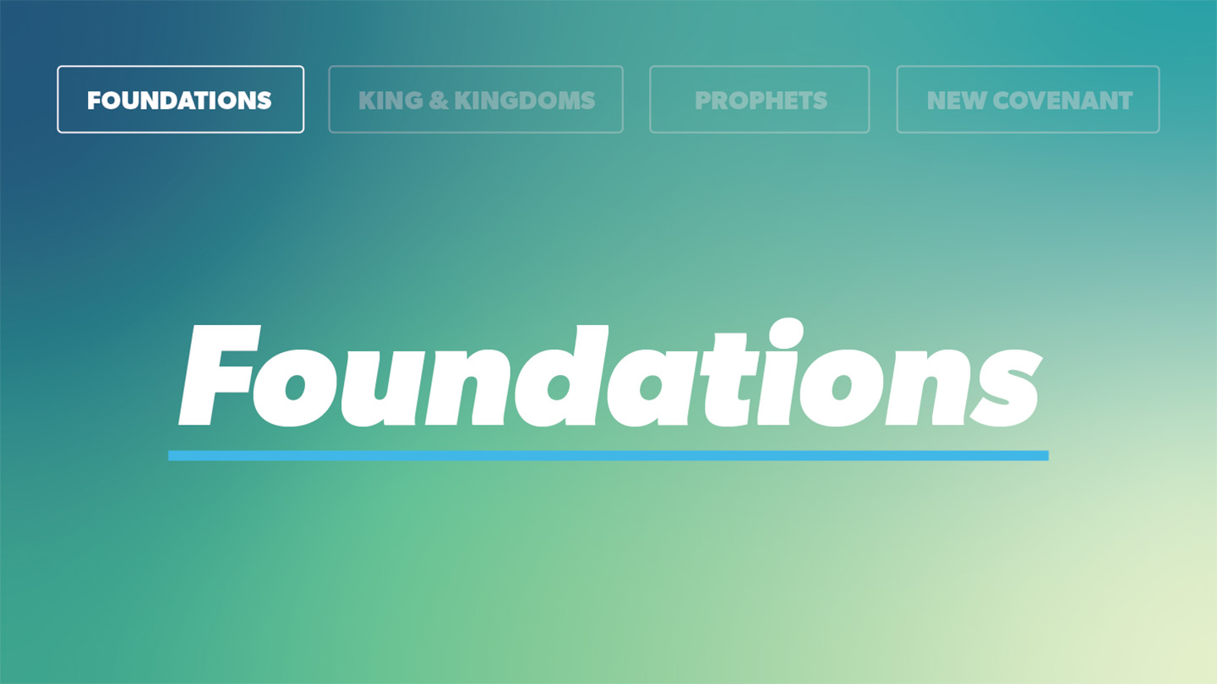

OPEN THE CONVERSATION
Take some time to build relationships with the students:
- Ask for each student’s high and low from the week.
- Optional Icebreaker Activity: Bullseye Challenge
Set up a simple target (this could be a drawn bullseye on a whiteboard or taped circles on the floor). Give students small objects (like a bean bag or crumpled paper) to throw at the target. Have each student take a turn aiming for the bullseye. After a few rounds, ask:
  - How hard was it to hit the exact center?
  - What made it difficult to hit the mark every time?
  - How does this activity relate to our walk with Christ?
INTRODUCTION
Archery has been practiced for thousands of years, requiring precision, skill, and focus. In competitions, even a slight miscalculation can cause an arrow to miss its target. Interestingly, the word "sin" originally came from an archery term that means "to miss the mark." In our spiritual lives, we "miss the mark" because of sin. We sin when we fail to fully love God and others. Instead, taking things into our own hands rather than trusting God’s ways. In our passage today, we’ll see how God instructs us to “put to death” the sin in our lives in order to live in a manner pleasing to Him. It’s a calling that requires personal sacrifice and hard work, but is made possible by the presence of the Holy Spirit in our lives, empowering and shaping us to be more like Jesus!
What kind of things cause us to miss the mark when it comes to following Jesus daily?
PASSAGE: Colossians 3:1-11
Read Colossians 3:1-4
- Consider Paul’s instruction to focus on things above (of God’s Kingdom) rather than on “earthly things.” What are some examples of “earthly things” that we might be tempted to seek? What does it look like practically to set our minds on things above instead?
Read Colossians 3:5-9
- Look at the sin Paul outlined in verses 5 and 8-9. How do you see these today? And what are some ways we can begin to put these things to death in our lives?
- In what ways can we actively seek out the renewal mentioned in verse 10? Why is it important we do this together and not in isolation?
Read Colossians 3:10-11
- In verse 11, Paul spoke about divisions the Colossian church faced in their everyday lives. What divisions exist for us in 2025? What are some ways we can help bring more unity in our community?
WRAP UP
Put today's lesson into action: How can we as a group support and encourage each other as we work to fight sin and focus on heavenly things, better orienting our lives toward Jesus?
Ask for any prayer requests and pray for one another.
EXTENDED CUT
- Consider Paul’s instruction to focus on things above (of God’s Kingdom) rather than on “earthly things.” What are some examples of “earthly things” that we might be tempted to seek? What does it look like practically to set our minds on things above instead? Paul’s words in Colossians 3:2— “Set your minds on things above, not on earthly things”—challenge us to focus on what really matters: God’s Kingdom. The world tells us to chase things like popularity, approval, success, material goods, or pleasure. The problem is, living in continual pursuit of any of these only leads to emptiness and disappointment because they lack any eternal value. Jesus put it this way in Matthew 16:24: “If anyone wants to follow after me, let him deny himself, take up his cross, and follow me.” When we focus on “things above,” we’re choosing to follow Jesus by putting Him first in our lives. Practically, this means living differently from the world around us. Instead of making decision based on our own desires, we seek what honors God. Instead of seeking after success or achievement to define our worth, we find our identity in Him and His truth. Setting our minds on things above means we live with a greater purpose, recognizing that our ultimate hope and joy are found in Jesus, not in the temporary things of this world. When we focus on what’s eternal—our relationship with God—we experience the true peace and fulfillment only He can give us.
- Look at the sin Paul outlined in verses 5 and 8-9. How do you see these today? And what are some ways we can begin to put these things to death in our lives today? Even though Paul wrote to believers of long ago, the list he provides is still very much applicable and relevant to our own lives today! For instance, it doesn’t take long to look around at our culture and notice examples of impurity or sexual immorality are everywhere. TV shows, movies, pop culture etc., all endorse following what feels good in the moment rather than disciplining ourselves to live in the way God calls us as his followers. And it’s just the same with the other sins Paul highlights, like anger and obscene talk. We have more opportunity today than ever to influence others with our words through things like social media. And yet, we’re more likely to see people tearing others down with their words, spewing anger, rather than building others up. Paul warned believers not to follow the ways of the world but to continue to put sinful practices to death. Sin is a problem because it separates us from God and acts as a roadblock to God’s good plan for our lives. Jesus said, “If your right eye causes you to sin, gouge it out and throw it away” (Matthew 5:29). Gouging out your eye requires radical sacrifice, and Jesus meant that we should be willing to make radical sacrifices to kick sin out of our lives! That might mean we choose NOT to watch the TV show that everyone else seems to be watching. Instead, we put up boundaries that keep us from dishonoring the Lord and being influenced by the ways of the world. Or maybe we choose to sacrifice social media, to keep ourselves from using our words unwisely or being drawn into jealousy and discontentment over the things we see as we scroll. Whatever the case, the sacrifice will always be worth it when we consider the eternal value of living for Christ over the temporary pleasure of living for the world.
- In what ways can we actively seek out the renewal mentioned in verse 10? Why is it important we do this together and not in isolation? The process of moving away from sin in our lives and actively seeking after God is a continual one—it requires ongoing dedication and sacrifices—but the process of salvation is immediate. When we accept Jesus into our lives, we receive “the new self” Paul mentioned in verse 10. Now that we are new creations in Christ, we are “being renewed” (v. 10). This is both active and ongoing. We aren’t renewed and perfected all at once. It’s a continuous work by the Holy Spirit in our lives. Renewal happens as we spend time with God—reading the Bible, praying, and letting His truth shape our thoughts and actions. But we can’t do this alone! God designed us to grow in our faith together. Hebrews 10:24-25 reminds us to “spur one another on toward love and good deeds” and to not give up meeting together. When we surround ourselves with other believers, we find encouragement, accountability, and support to help us grow.
- In verse 11, Paul spoke about divisions the Colossian church faced in their everyday lives. What divisions exist for us in 2025? What are some ways we can help bring more unity in our community?
In verse 11, Paul reminds believers that in Christ, divisions based on background, status, or identity don’t define us—Jesus does. Today, we still face divisions in many areas, like social status, race, political views, or personal differences. In school you may experience division through cliques or bullying. Even in the Church, people can be divided by opinions or disagreements on certain topics. But as followers of Jesus, we’re called to live in unity. Ephesians 4:2-3 tells us to be “completely humble and gentle; be patient, bearing with one another in love. Make every effort to keep the unity of the Spirit through the bond of peace.” We can help bring unity by treating others with respect, listening with humility, and focusing on what brings us together—our faith in Jesus—rather than what separates us. When we love like Jesus, we break down barriers and help create a community that reflects His Kingdom to a watching world!

