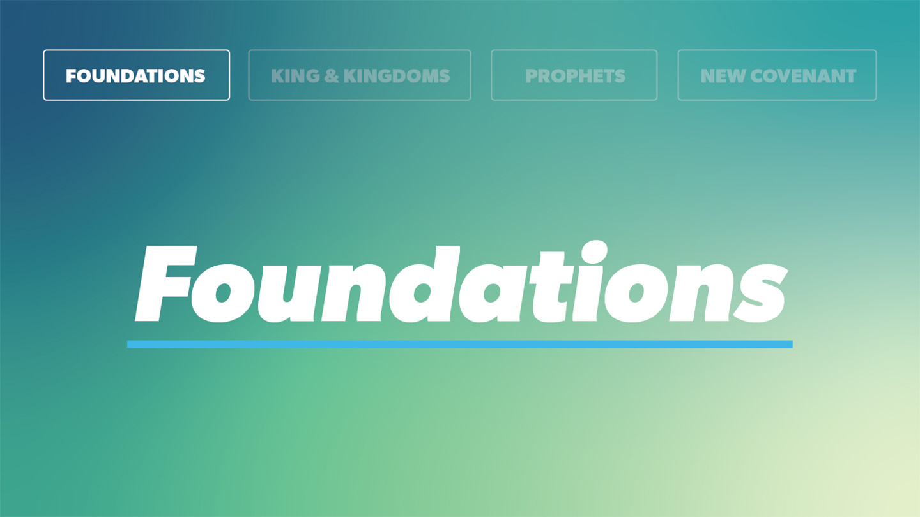

OPEN THE CONVERSATION
Take some time to build relationships with the students:
- Ask for each student’s high and low from the week.
- Today’s RBQ (Relationship Building Question): What is something you slowly got more and more into over time, without really planning on it? (A show, a game, a sport, music, a habit, etc.)
INTRODUCTION
If you have ever watched a football game long enough, you have probably seen momentum shift. One team looks flat, the other looks unstoppable, and then one play changes everything. A turnover. A big stop on third down. A long return. Suddenly the energy flips. The team that was struggling starts believing again, and the game starts moving in a different direction.
Life can work a lot like that too, even if the shift is slower and harder to see. You rarely wake up one day and decide to completely change who you are or what you care about. It usually happens slowly. What you give your time to starts shaping your habits. What you focus on starts shaping what you want. Over time, your life starts leaning in a direction, whether you meant it to or not.
In 1 John 2:17, John puts words to that reality. He reminds us that a lot of what we chase does not last. The world and its desires are passing away. But he also points us toward something better. The one who does the will of God remains forever. That verse is not just about turning away from things that pull us down. It is also about leaning into a different way of living, where small steps of trusting and obeying God begin to shape the direction of our lives.
So this is less about being perfect and more about the direction your life is moving. Are you being pulled along by whatever is in front of you, or are you slowly learning to want what God wants? As we look at this verse, and as our church steps into a focused season of prayer, we have a chance to think honestly about where our lives are heading, and what it might look like to move toward Christ.
READ 1 JOHN 2:15-17
- When you hear that “the world and its desires are passing away,” what does that make you think of in everyday life? What are some things people chase that feel important now but will not really matter in the long run?
- John says the one who does the will of God remains forever. What do you think it looks like to start building your life around what matters to God?
- If someone watched a highlight reel of your week, what might they say your life is about right now? What would they think you are moving toward?
- What is the difference between trying to be a “perfect Christian” and taking small, honest steps of obedience over time? Which one do you think John is pointing toward here?
- Our church is starting forty days of prayer together. How could choosing to consistently lean into that help build spiritual momentum and change what you turn to first when life feels stressful or confusing?
WRAP UP
Ask for prayer requests and pray together. As you move into this season, ask God to show you where your heart is leaning and to help you take even small steps toward Him.

EXTENDED CUT
1 John is written to believers who were dealing with confusion about what it really meant to know God. Some people were claiming to walk with God while living in ways that did not match His character. Others were spreading wrong ideas about Jesus. John writes like a spiritual father, wanting to clear things up and encourage a real, authentic walk with God.

In 1 John 2, when John talks about “the world,” he is not saying that creation itself is bad or that we should hate people. He is talking about a way of life that pushes God out of the center and puts our desires in His place. He describes it in terms of cravings, what we see and want, and pride in what we have. It is the mindset that says, “I will build my life on what I feel, what I see, and what I own,” instead of on who God is and what He says.

Verse 17 is where John steps back and shows the bigger picture. The world and its desires are “passing away.” The language there points to something that is already in motion. What looks solid and impressive now is temporary. It is fading, even if it does not look like it yet. That is the “already and not yet” tension. The system that leaves God out is already on its way out, even if we still feel its pull.

In contrast, the one who does the will of God “remains forever.” John is not teaching that we earn eternal life by being good enough. The rest of the letter makes it clear that eternal life is a gift through Jesus. But he is saying that a life shaped by God’s will is tied into something lasting. When God’s love is at work in someone, it changes what they live for. Their life is no longer just driven by passing desires, but by a relationship with the One who does not fade.

This verse invites us to look beyond the moment. It asks us to think about what we are giving our hearts to, and whether those things can hold up over time. It is not calling us to perfection, but to a different direction, away from things that are already fading, and toward the God whose will and presence endure.
1. When you hear that “the world and its desires are passing away,” what does that make you think of in everyday life? What are some things people chase that feel important now but will not really matter in the long run?
You might think of things like what people think about you, popularity, certain trends, accomplishments. Those things can feel huge right now, but they change fast. They can be good in their place, but they cannot carry your identity or your hope. This verse is a reminder that if you build everything on what is temporary, you end up empty when it fades.

2. John says the one who does the will of God remains forever. What do you think it looks like to start building your life around what matters to God?
It does not mean you never enjoy anything or that life turns into a list of rules. It means you start letting what God cares about influence your choices. That might look like choosing integrity when cheating or lying would be easier, loving people even when they are not easy to love, or making space for God in your day. It is about thinking beyond “right now” and asking, “Is this drawing me closer to God.”
3. If someone watched a highlight reel of your week, what might they say your life is about right now? What would they think you are moving toward?
A person might say, “You are all about sports,” or “You are always on your phone,” or “You care a lot about friends and hanging out.” None of that is automatically bad, but this question can help you see what your time and energy are actually going toward. It can be uncomfortable to think about, but it is honest. It reveals what has your attention and what your current direction might be.

4. What is the difference between trying to be a “perfect Christian” and taking small, honest steps of obedience over time? Which one do you think John is pointing toward here?
Trying to be a “perfect Christian” often leads to pressure, fake behavior, or hiding when you mess up. It is focused on performance. Small steps of obedience are more about direction. You are not pretending to have it all together. You are just choosing, again and again, to trust God in real areas of your life. John is pointing toward that kind of life. A life that is not flawless, but is slowly being shaped by God’s will instead of by passing desires.

5. Our church is starting forty days of prayer together. How could choosing to consistently lean into that help build spiritual momentum and change what you turn to first when life feels stressful or confusing?
If you build a simple habit of praying during those forty days, even if it is short and honest, you might notice that you start turning to God faster. Instead of only going to your phone, friends, or distractions when you are stressed, you begin to bring things to Him. Over time, that can change what feels natural to you. Those small, repeated moments of prayer can start to build spiritual momentum, because you are involving God in what is happening instead of trying to handle it all on your own. As that grows, turning to God becomes less of a last resort and more of your first response.

