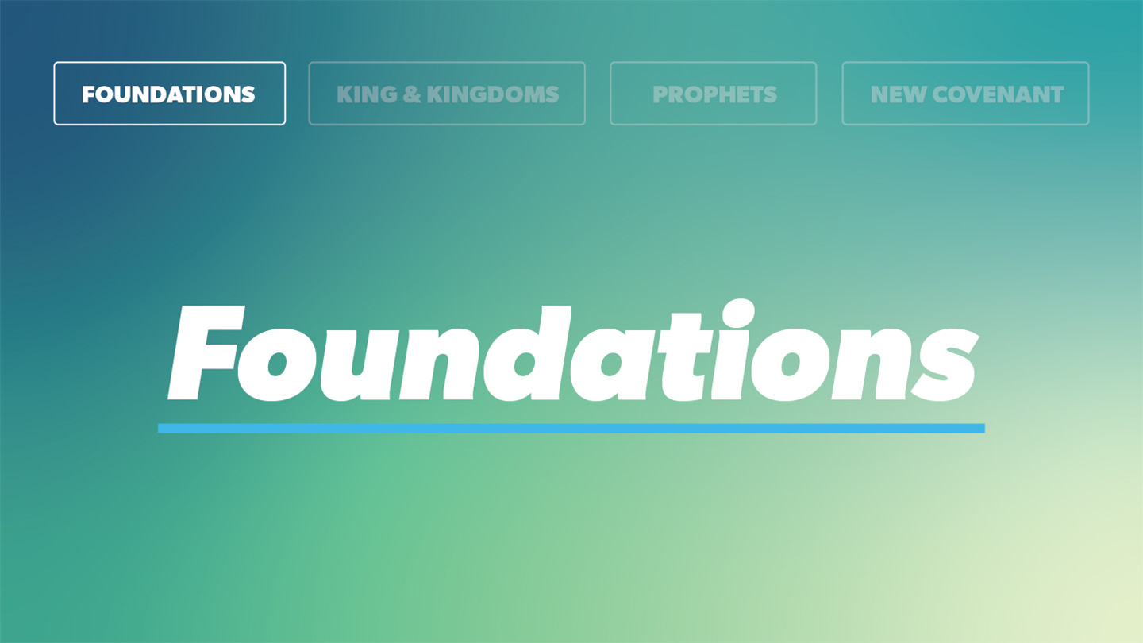

OPEN THE CONVERSATION
Take some time to build relationships with the students:
- Ask for each student’s high and low from the week.
- Today’s RBQ (Relationship Building Question): What is something in your house that is way more important than it looks? (It could be sentimental, useful, or just surprisingly important).
INTRODUCTION
There are people and things in life that you may not really notice until they are missing. Maybe it is the person who always runs the sound at church, the teammate who does not score but makes everyone else better, or the friend who quietly checks in on people. They might not always get attention, but if they were suddenly gone, you would feel it.
Most of the time, we pay more attention to what is loud and obvious than to what is actually holding things together. But foundations matter. What you build your life on, and who you are connected to, shapes everything else.
In 1 Peter 2, Peter uses that kind of picture to describe Jesus and His people. He calls Jesus the “living stone” and the cornerstone, the one everything else has to line up with. And then he says that we, as believers, are “living stones” being built into a spiritual house. This is not just about what we believe privately. It is about who we belong to together, and who our lives are meant to point toward. Today’s passage is about identity. Who Jesus is. And who we are because of Him. Our lives are not random or disconnected. God is forming us into something; a people who belong to Him, built on Christ, and called to reflect His goodness in the way we live.
READ 1 PETER 2:4
- Peter describes Jesus as rejected by people but honored by God. Where do you see that same tension today between what people value and what God values?
READ 1 PETER 2:5
- Peter says we are “living stones” being built into something together. How does seeing yourself as part of what God is building change the way you think about your place in the church or your community of believers?
READ 1 PETER 2:6-10
- Peter says Jesus is the cornerstone, someone people either build on or stumble over. What helps someone build their life on Christ instead of tripping over Him like many do?
- Peter uses identity words like chosen race, royal priesthood, holy nation, and people belonging to God. Which of these speaks to you most right now, and how does it reshape the way you see yourself?
- Peter says God brought us “out of darkness into His marvelous light” so that we would proclaim His praises. What is one real way your life could point someone toward Jesus this week, not by being perfect, but by being faithful?
WRAP UP
Ask for prayer requests and pray together. Ask God to help each of you stay connected to Christ as your foundation and to live in a way that shows His goodness to the people around you this week.

EXTENDED CUT

1 Peter is written to believers who were scattered and suffering. Many of them were facing pressure, misunderstanding, and even persecution for their faith. Peter writes to encourage them and remind them who they are in Christ, so they do not lose heart or forget their identity.

In 1 Peter 2:4–10, Peter uses building and temple imagery that would have been familiar to his readers. He calls Jesus a “living stone.” Stones in a building are not alive, but this one is. Jesus is risen and active. He is also the cornerstone. In the ancient world, the cornerstone was the first and most important stone in a building. Everything else was aligned to it. If the cornerstone was off, the entire structure would be unstable. Peter is saying that Jesus is the reference point for the church and for our lives. He was rejected by people, but chosen and honored by God. That echoes passages like Isaiah 28:16 and Psalm 118:22.

Peter then shifts and calls believers “living stones” being built into a spiritual house. Instead of a physical temple made of bricks, God is building a spiritual temple made of people. This continues a theme in the New Testament that sees the church as the dwelling place of God’s presence, not a building but a people. The idea of believers as a “holy priesthood” points back to the Old Testament priesthood, but now applied to all who are in Christ. Every believer has access to God and is called to offer “spiritual sacrifices,” which include obedience, praise, service, and lives devoted to Him.

In verses 6–8, Peter quotes several Old Testament passages to show how Jesus fulfills prophecy. The stone imagery from Isaiah 28:16, Psalm 118:22, and Isaiah 8:14 highlights that Jesus is both the foundation for those who believe and a stumbling stone for those who reject Him. There are only two responses to the cornerstone: faith or rejection. For those who trust in Him, there is honor and security. For those who reject Him, there is stumbling and judgment.

Verses 9–10 draw heavily from Old Testament language about Israel, especially from Exodus 19 and Hosea. Peter calls believers a “chosen race, a royal priesthood, a holy nation, a people for His possession.” In Christ, God has formed a new people, made up of Jews and Gentiles, who now share in this identity. They have been called out of darkness into God’s marvelous light. Once they were not a people, but now they are God’s people; once they had not received mercy, but now they have received mercy. This is a powerful picture of conversion and belonging.

All of this reinforces Peter’s main point: Jesus is the cornerstone, and those who trust in Him become part of what God is building. They do not belong to the darkness anymore. They belong to God. And their purpose is to proclaim His praises: to reflect His character and make His goodness known in the world.
1. Peter describes Jesus as rejected by people but honored by God. Where do you see that same tension today between what people value and what God values?
A lot of what people value today revolves around image, popularity, success, or how impressive someone looks. But God values things like humility, faithfulness, honesty, and love. When you follow Jesus, you will not always fit into what culture celebrates. Sometimes you may feel out of step or overlooked because the things God values are often quieter and deeper. This verse reminds you that God’s approval matters more than people’s opinions, and that Jesus Himself walked a path that many didn’t understand.

2. Peter says we are “living stones” being built into something together. How does seeing yourself as part of what God is building change the way you think about your place in the church or your community of believers?
It means your faith is not just a solo project. God is doing something bigger than your individual life, and He has chosen to include you in it. You are meant to be connected, supported, and shaped alongside other believers. This helps you see church and community as more than events you attend. It becomes a family and a purpose you share. When you show up, serve, encourage someone, or even just pray with others, you strengthen the “house” God is building. Your presence has weight and meaning.
3. Peter says Jesus is the cornerstone, someone people either build on or stumble over. What helps someone build their life on Christ instead of tripping over Him like many do?
Building your life on Christ means trusting who He is and letting His teaching shape your identity and choices. People often stumble when they want control or resist what Jesus calls them to do. But trust grows when you come to Him honestly, stay connected to His people, and let His Word guide you even when it challenges you. It is a slow process of choosing to let Him set the direction for your life. Over time, that creates a foundation that is steady and strong instead of shaky and easily knocked over.

4. Peter uses identity words like chosen race, royal priesthood, holy nation, and people belonging to God. Which of these speaks to you most right now, and how does it reshape the way you see yourself?
Different phrases will stand out to different people. “Chosen” might hit someone who sometimes feel overlooked. “Royal priesthood” may remind you that you have direct access to God and a role to play in His work. “People belonging to God” might reassure someone who feels disconnected or unsure of where they fit. Peter’s point is that your identity does not come from labels others give you or mistakes you’ve made. God names you, claims you, and sets you apart with purpose. Letting these truths sink in can shift how you see yourself and how you move through your day.

5. Peter says God brought us “out of darkness into His marvelous light” so that we would proclaim His praises. What is one real way your life could point someone toward Jesus this week, not by being perfect, but by being faithful?
Pointing people to Jesus does not always mean giving a speech about Him. It can be as simple as choosing kindness when it would be easier to be sharp, owning your mistakes instead of hiding them, praying for someone who is going through something hard, or giving God credit when someone asks how you are doing. When your actions and words reflect humility, honesty, and love, people notice. These small, faithful choices can give others a clearer picture of who Jesus is and who you belong to.

