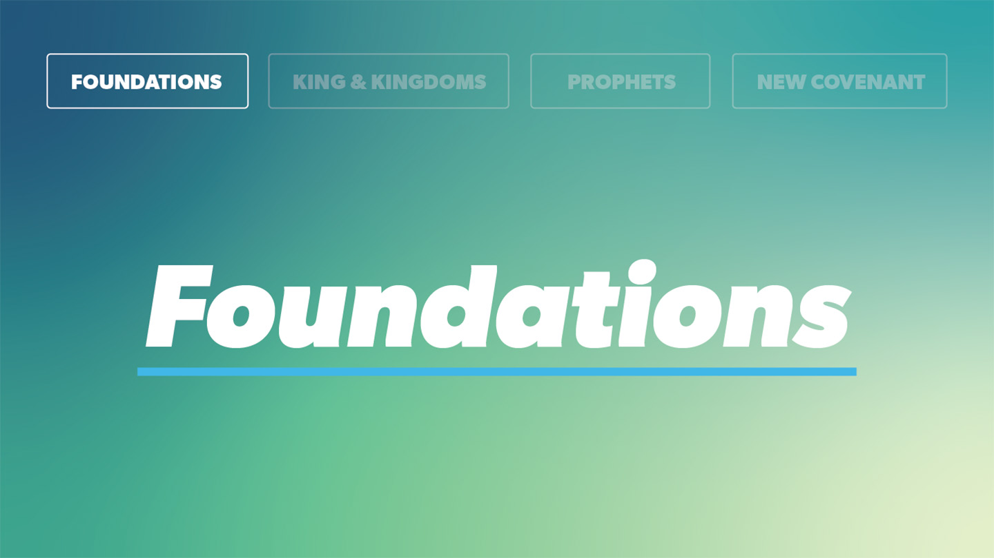

OPEN THE CONVERSATION
Take some time to build relationships with the students:
- Ask for each student’s high and low from the week.
- Today’s RBQ (Relationship Building Question): What is something small that can instantly make your day better?
INTRODUCTION
It’s pretty easy to slip into thinking that if one or two things were different, life would feel better. If you had more money, more freedom, better grades, different friends, a different body, a different family situation, or just something to look forward to, then maybe you would finally feel settled. Most people do not say it out loud like that, but the feeling is there.
The hard part is that even when people get what they wanted, it usually does not fix as much as they thought it would. You can still feel restless. You can still compare yourself to other people. You can still feel like something is missing.
That is part of why contentment is hard. It is not just about whether you have enough stuff. It is about where your heart is looking for peace. Proverbs gets right to that. It does not pretend wanting more is a small issue. It shows that contentment is tied to trusting God, receiving what He gives, and learning not to build your life around whatever looks like it will satisfy you next.
Real contentment is not found in finally having everything you want. It is found in the Lord. And as Christians, we know that contentment is ultimately found in Christ, because He is the One who gives us what more money, more comfort, more success, or more approval never can.
READ PROVERBS 19:23
- Proverbs 19:23 connects the fear of the Lord with life and contentment. What do you think that means? How is that different from the way people usually think about a good life?
- When people are chasing contentment in the wrong places, what do they usually look to? Why do you think those things still leave people wanting more?
READ PROVERBS 30:7-9
- Why do you think this prayer asks God for neither poverty nor wealth? What does that show about how both having too much and not having enough can affect a person’s heart?
- What do you think it looks like to trust God for what you need, especially when life feels hard or uncertain?
READ PROVERBS 21:17
- What are some things people chase because they think it will make life feel better? How can those things start to shape a person’s choices over time?
WRAP UP
This week, pay attention to where discontent keeps showing up in your life. Bring that honestly to God, and ask Him to help you find contentment in Him.

Take a moment to share prayer requests and pray together.

EXTENDED CUT

Proverbs is a book of wisdom for ordinary life. It is not written like a long story or a letter, but as a collection of sayings that help people learn how life generally works under God. Proverbs doesn’t pretend every situation is simple, and individual proverbs should not always be read like automatic promises. They are wise observations about the kind of life that usually follows from trusting God or ignoring Him. In these verses, that wisdom is connected to contentment.

Proverbs 19:23 says that the fear of the Lord leads to life, and that the one who has it rests satisfied. The fear of the Lord is not mainly about being terrified of God. In Proverbs, it means seeing God rightly, taking Him seriously, and living with reverence toward Him. It shows up in walking in His ways, loving Him, worshiping Him, and letting His wisdom shape the way we live. That matters for contentment because a restless heart often comes from trying to carry a role we were never meant to carry. When someone lives with God at the center, life is no longer built around getting everything they want or holding everything together themselves.

That doesn’t mean life becomes easy or that every problem disappears. Proverbs is not saying people who fear the Lord never face hardship. It is saying that life with God gives a person something deeper than circumstances. Contentment is not the same as getting everything you want. It has more to do with being settled in the Lord even when life is not exactly what you would have chosen.

Proverbs 30:7-9 gives one of the clearest prayers about contentment in Scripture. The prayer asks God to keep falsehood away and to give neither poverty nor wealth, but only the food that is needed. That prayer is honest about the danger on both sides. Having too much can make a person forget God and act like he does not need Him. Having too little can bring its own temptations and pressures. The point is not that money is evil or that comfort is always wrong. The point is that both plenty and lack can expose what the heart is trusting.

That prayer also sounds close to the kind of dependence Jesus teaches in the Lord’s Prayer when He tells His disciples to ask for daily bread. It is a simple request, but it pushes against the way people usually think. Most people want enough to feel secure far into the future. Proverbs 30 teaches a different kind of trust. It asks for what is needed and leaves the rest with God. It also cares about God’s name, because both pride and desperation can lead a person away from honoring Him.

Proverbs 21:17 warns about a life built around pleasure and indulgence. The issue is not that every enjoyable thing is automatically wrong. The issue is what happens when getting what feels good becomes the thing someone keeps chasing. Over time, that kind of life shapes a person’s decisions. It can make wisdom feel boring, self-control feel unnecessary, and contentment feel almost impossible.

That’s why contentment is so difficult. Discontent rarely feels like rebellion at first. It often feels normal. It sounds like, “If I just had that, I would be okay,” or “Once this part of my life changes, then I will be satisfied.” But Proverbs keeps pressing deeper than the thing itself. The question is not only what someone wants, but what they are asking that thing to do for them.

God gives good things, and those things can be received rightly. But no created thing can carry the weight of being someone’s source of life, peace, or identity. Contentment grows when the Lord becomes the center instead of the gifts He gives. That is why this lesson ultimately points to Christ. The heart was not made to be satisfied by having enough or enjoying enough. It was made for God Himself.

1. Proverbs 19:23 connects the fear of the Lord with life and contentment. What do you think that means? How is that different from the way people usually think about a good life?
It means contentment starts with knowing God rightly and living in trust under Him. In Proverbs, fearing the Lord is not about being scared of Him. It is about taking Him seriously, loving Him, and letting your life be shaped by who He is. That’s pretty different from the way people usually think about a good life. Most people think contentment comes from having enough money, enough freedom, enough success, or enough comfort. Proverbs points us somewhere deeper than that.
2. When people are chasing contentment in the wrong places, what do they usually look to? Why do you think those things still leave people wanting more?
A lot of people look to money, relationships, attention, comfort, success, or just the next thing they think will make life feel better. Some of those things are not bad by themselves, but they were never meant to give people lasting peace. They usually leave people wanting more because they do not really settle the heart. Once you get one thing, it is easy to move on to the next thing and think that will be the answer.

3. Why do you think this prayer asks God for neither poverty nor wealth? What does that show about how both having too much and not having enough can affect a person’s heart?
This prayer is honest about both sides. Having too much can make someone forget how much they need God. Not having enough can bring real pressure, fear, and temptation too. So the prayer is not saying money is bad or that struggling is somehow better. It’s asking God for what is needed and for a heart that keeps trusting Him either way.

4. What do you think it looks like to trust God for what you need, especially when life feels hard or uncertain?
Trusting God for what you need means coming to Him honestly instead of acting like you have to figure everything out yourself. In Proverbs 30, the prayer is not asking for everything to be easy. It is asking God to provide what is needed and to keep your heart from drifting away from Him. That matters when life feels hard, because fear can make us think we will only be okay if everything changes first. Contentment means learning to bring today’s needs to God and trust that He knows how to care for you.

5. What are some things people chase because they think it will make life feel better? How can those things start to shape a person’s choices over time?
People might chase comfort, attention, entertainment, popularity, money, relationships, or whatever helps them avoid feeling bored, stressed, or left out. Those things can start shaping a person’s choices when they become what someone is always looking for first. Over time, a person can make decisions around what feels good in the moment instead of what is wise, faithful, or actually good for them. Proverbs is warning that a life built around pleasure does not usually lead to contentment. It usually leaves people wanting more.

