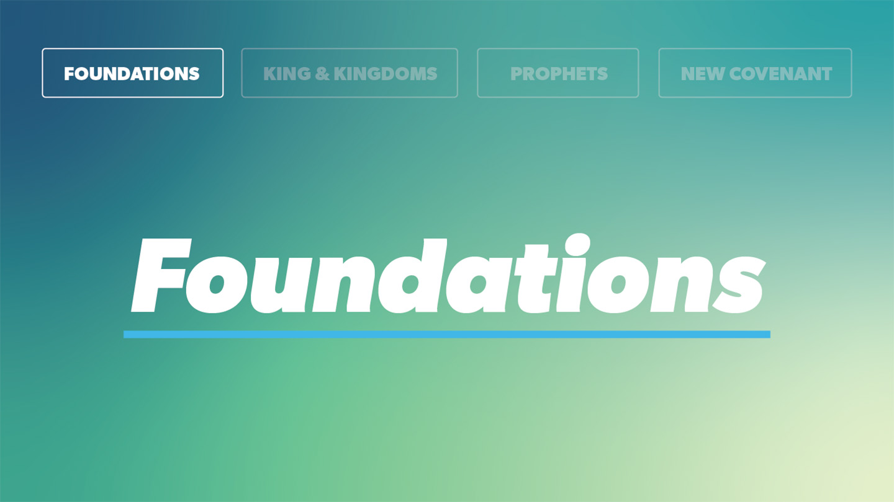

OPEN THE CONVERSATION
Media is full of people claiming to be experts in some kind of health, and there truly is some great wisdom being shared out there. But much of it is just hype and marketing genius. What is the most ridiculous thing you’ve ever seen or heard of people doing to be more “healthy”?
INTRODUCTION

Where do you go first when you need some information about how to live the best life you can? Do you ever think of praying first? Why or why not?

We need the wisdom of God for living physically, mentally, and spiritually healthy lives. But we need His wisdom even more for the heart needs, hopes, dreams, and knowledge that motivate these quests. There’s nothing wrong with looking for good information about nutrition, rest, exercise, mental health, stress relief and more. Remember though, that even good pursuits can take the attention of our hearts away from Jesus. Simply spending time with Him in His word and following His commands addresses everything we need, in a more deep and healing way than is offered by any other approach. When we search for good advice on how to thrive in our lives here on earth, we can keep idolatry at bay by seeking the things of God as first priority. After all, God did design everything about our bodies and the physical world! He can be trusted to give us good guidance for how to live in it. The key to flourishing in our health is living wisely, in step with the Lord.

Why does it make sense to be mindful of God’s guidance first related to our health and contented, joyful living? What can cause you to hesitate in trusting the God knows best what you need to be well?
READ Proverbs 3:1-10
- What do you picture when you think of living a full life? Answer with one thing that might change with time, and one thing that won’t change, no matter your age.
- What does it mean to trust God with all of your heart? How does this trusting lead to bringing Him into all your priorities and decisions?
- What would lit look like for you to prepare today to learn God’s “voice” (or how He guides) better for the coming tomorrows?
- What promise does this passage offer?
- What warning is included in verses 11-12? What are some ways a person might misunderstand this promise?
- What does it look like practically for you to bring your first and best to God?

WRAP UP

Put today's lesson into action: How can you apply it to your life?
Ask God to make you more willing to learn from Him about how walking with Him is best for you. What is one thing about your mental, physical, or spiritual health that you can surrender to God in a deeper way today?

You can ask God to simply show you more about yourself and your soul, impress truth on your heart from His Word, and help you to trust Him more. Write down anything He calls to your mind, either immediately or over time. He may speak to your heart about these things as you continue faithfully reading His Word in Scripture. We can trust He is bringing healing and wholeness to us as we spend time with Him.
Ask for any prayer requests and pray for one another.

EXTENDED CUT
When it comes to health and flourishing, people can tend to view God’s part in it as a last resort after we’ve tried all the other things we can think of (or purchased) to bring health. We must resist the urge to think of God as a vending machine to dispense the specifics we ask for related to our flourishing and think of Him as the most qualified Guide and Friend to walk with us along the way. As we walk with Him in worship, prayer and spending time with Him in His word He brings about wholeness…it’s just who He is.
We would do well to stop seeking a life here that can be perfect and uncorrupted by decay, disease, and death. It’s just not going to happen—this is one of the great griefs of sin entering the world with Adam and Eve. Rather than buying the lie that if we just eat the right way for long enough, take the right supplements, devote ourselves to the right exercise and therapy programs we can somehow have more control than we do, let’s lean into walking with God, trusting the God will provide the care we need. He may likely even use some of these same tools we often seek first. But let’s never trust the tools more than we trust Him in His rightful place as Healer in our hearts.
In Proverbs we see Solomon (one of the wisest and best resourced people ever to live, writing by the Holy Spirit’s leading) imploring all people to live according to God’s ways in order to provide the best possible life on earth and certain joyful eternity in heaven. Though He lived before Jesus on the earthly timeline, he knew active faith in God’s promised redemption is what saves people for eternity and brings abundant life to our days on earth.
Solomon noted that living according to God’s ways will bring “many days” (v. 2). Living wisely certainly has the potential to lengthen our lifespan, though it’s not necessarily guaranteed. What is guaranteed, though, is a full quality of life and well-being. Can you look around and see how our society yearns for these things? How nonbelievers seek them in the wrong places? We cannot hope to truly have a full life or well-being apart from Christ.
The Hebrew word translated as “loyalty” in verse 3 is chesed.4 We also see it translated as faithful love, fidelity, and kindness. It’s the same word God used to describe the incredible love He has for His people: . . . but showing faithful love to a thousand generations of those who love me and keep my commands. —Exodus 20:6 This type of loyal love and faithfulness is critical if we want to flourish in our health.
Scripture offers us many tidbits of wisdom about where we should place ultimate trust:
Anyone trusting in his riches will fall, but the righteous will flourish like foliage. —Proverbs 11:28
The one who trusts in himself is a fool, but one who walks in wisdom will be safe. —Proverbs 28:26
Scripture also contains warnings about doing what we think is right, apart from the Lord:
There is a way that seems right to a person, but its end is the way to death. —Proverbs 14:12
To flourish in any area of life, fully trusting in the Lord is critical. This means turning to Him when you’re making decisions. Being obedient to what He is calling you to do versus doing strictly what you want to do. Our “own understanding” here simply means relying on our own reasoning instead of God’s. The more we actively invest in our relationship with the Lord by studying our Bibles, praying, meditating, fasting, etc., the more tuned in we will become to the daily workings and nudges of the Holy Spirit. The best decision we can make for tomorrow’s decisions is investing in our relationship with the Lord today.
Look at Proverbs 3:5-6 again. It’s worth noting that the fruit we experience of God making our “paths straight” comes AFTER we trust Him with all our hears and trust his wisdom more than we trust our own. Even so, it’s so tempting to try to control what our paths should look like. We can trust that His paths for us are best (and we can trust Him to define what “best” means.) The straight paths in view here are the paths of righteousness David wrote about in Psalm 23. This is the wise path of right living, which leads to God’s will being walked out, which we know is for our ultimate good (Romans 8:28)
Fully trusting the Lord with our lives includes trusting Him with our possessions. We’ve studied this concept in this series previously, and Scripture will continue to reiterate this idea! The offering of the firstfruits was a part of God’s law (Deuteronomy 18:4). This practice took immense trust of God’s provision. A person wasn’t to wait and see how much the harvest would yield, making sure they had enough to care for family and workers, and then offer some to God. No, they offered the, and, with a humble heart, trusting that God would provide for them and everyone they were responsible for. When we honor God with our blessings and wealth (all gifts from Him in the first place), it honors Him.
Proverbs teaches us how to live wisely and well, a task we can’t hope to accomplish when we aren’t in relationship with the Lord (the source of wisdom). Living in close relationship with the Lord, with our very lives characterized by Christlike love and faithfulness to the Lord, is the key to “a full life, and well-being” (v. 2). This is how we truly live in health. This requires us to place our full and complete trust in the Lord (with ourselves and our possessions).

