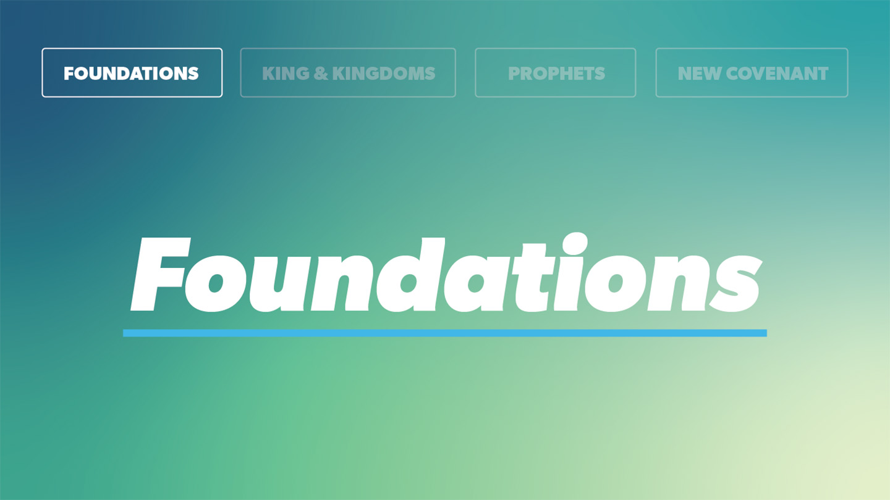

OPEN THE CONVERSATION
Take some time to build relationships with the students:
- Ask for each student’s high and low from the week.
- Today’s RBQ: Would You Rather (Integrity Edition)
  - Ask students which they would choose and why:
    - Lose every game but be known as the best teammate OR win every game but everyone knows you cheated?
    - Admit you made a mistake or have someone else find out on their own?
    - Tell a difficult truth or keep a lie that makes life easier?
    - Have everyone trust you or have everyone admire you?
    - Be famous for a year or respected for a lifetime?
    - Do the right thing and no one know about it or get recognized for doing something good?
    - Be successful or be trustworthy?
INTRODUCTION
Imagine you're taking a test at school. The answers are sitting on the desk next to you. Your teacher isn't looking, your friends are cheating, and no one would ever know if you copied a few answers. What do you do? The decision you make in a moment like this might not seem like a big deal, but the Bible passage we’ll look at today is going to show us something different. We’ll see that it’s actually the small decisions that no one sees, that reveal something important about who we’re becoming. It's easy to make good choices when we know other people are watching. But real character is revealed in the everyday choices we make when no one else knows what we're doing. We’ll see as we read through Proverbs 11:1-7 that God delights in people who are honest, humble, and full of integrity.
How would you define good character?
READ PROVERBS 11:1-7
- What does this passage teach us about the kind of qualities God values in a person’s character? In what ways does this line up or look different with what you thought?
- In this passage we see how much the Lord values honesty, yet we live in a culture that tends to promote deceit if it helps you get ahead. What are some ways you see peers act dishonestly at school, home, with friends, on their team, or social media etc.? Why is it important that we resist the temptation to do the same as followers of Jesus?
- According to verse 2, what is the difference between pride and humility? How does pride show a lack of trust in God and dependence on Him?
- Integrity means doing the right thing even when no one is watching. What’s one way you could grow in choosing integrity this week?
- Jesus lived a completely perfect life. How does knowing that our righteousness comes from Him (2 Cor. 5:21)– not our own perfection – help us when we fail?
WRAP UP
Put today's lesson into action: How can you apply it to your life?
Ask for any prayer requests, and pray for one another.

EXTENDED CUT
- What does this passage teach us about the kind of qualities God values in a person’s character? In what ways does this line up or look different with what you thought? Proverbs 11 teaches that God values people who are honest, humble, and full of integrity. Instead of trying to get ahead by cheating, lying, or putting themselves first, God delights in people who choose to do what is right, even when it's difficult or when no one else is watching. While the world often rewards based on appearances or achievements, God looks at the heart and desires people whose lives reflect His truth, justice, and righteousness. As followers of Jesus, we grow in these qualities not by trying harder to be perfect, but by allowing Him to transform our hearts so our everyday choices reflect His character.

- In this passage we see how much the Lord values honesty, yet we live in a culture that tends to promote deceit if it helps you get ahead. What are some ways you see peers act dishonestly at school, home, with friends, on their team, or social media etc.? Why is it important that we resist the temptation to do the same as followers of Jesus? There are a lot of different ways that you might experience pressure to bend the truth, especially if it seems like it will make life easier or help you succeed. It could look like cheating on homework or tests, copying someone else's work, lying to parents about where you are, pretending to be someone you’re not on social media, or cutting corners in sports or at work. While these choices may seem small in the moment, they slowly shape our character. As followers of Jesus, we're called to live differently because our goal isn't simply to get ahead, it's to become more like Christ and to ultimately give HIM the glory rather than ourselves. Choosing honesty builds trust with others, reflects God's character, and shows that our confidence is in Him rather than in what we can gain through dishonest shortcuts. Even when telling the truth or doing the right thing costs us something, we can trust that honoring God is always worth it because our identity and security are found in Jesus, not in success, popularity, or approval from others.

- According to verse 2, what is the difference between pride and humility? How does pride show a lack of trust in God and dependence on Him? Proverbs 11:2 shows us that pride and humility lead people in two very different directions. Pride says, "I've got this. I don't need anyone's help," while humility recognizes, "I need God, and I can learn from others." Pride often causes people to think they know best, making it difficult to admit mistakes, accept correction, or ask for help. And the result we see in this verse is that it leads to our disgrace. But humility, on the other hand, allows us to grow in wisdom and godliness because we're willing to listen and learn from both God and others. Instead of placing our confidence in our own abilities, plans, or opinions; humility softens our hearts to seek God’s wisdom and guidance! As followers of Jesus, we're called to imitate His example of humility (Philippians 2:3-8), remembering that true strength isn't found in proving ourselves but in trusting God, surrendering in obedience to his plans, and allowing Him to shape our lives.
- Integrity means doing the right thing even when no one is watching. What’s one way you could grow in choosing integrity this week? Integrity isn't built in one big decision; it's formed through the small choices we make every day. This week, think about one area where you might be tempted to take the easy way out instead of doing what's right. Maybe it's owning up to a mistake instead of making excuses, keeping a promise, treating a sibling with kindness, or choosing not to hide something from your parents. Remember, integrity isn't about being perfect; it's about consistently choosing to honor God, even when it's inconvenient or no one else would know. Every time we choose honesty over shortcuts, humility over pride, and obedience over convenience, we're becoming more like Jesus. Ask God to give you the courage to do what's right this week, trusting that pleasing Him is far more valuable than impressing others.

- Jesus lived a completely perfect life. How does knowing that our righteousness comes from Him (2 Cor. 5:21)– not our own perfection – help us when we fail? Knowing that our righteousness comes from Jesus is one of the most encouraging truths of the gospel. No matter how hard we try, none of us can be perfect. We all sin, make mistakes, and fall short of God's standard (Romans 3:23). But because Jesus lived the perfect life we never could and died in our place, God sees everyone who trusts in Him as righteous (2 Corinthians 5:21). That means when we fail, we don't have to hide in shame or believe that God has given up on us. Instead, we can honestly confess our sin, receive His forgiveness, and keep growing! Our relationship with God isn't based on our performance, it's based on what Jesus has already done for us. Rather than making us careless about sin, God's grace motivates us to love Him more and pursue a life that reflects His character. We obey God not to earn His love, but because we have already received it through Christ!

