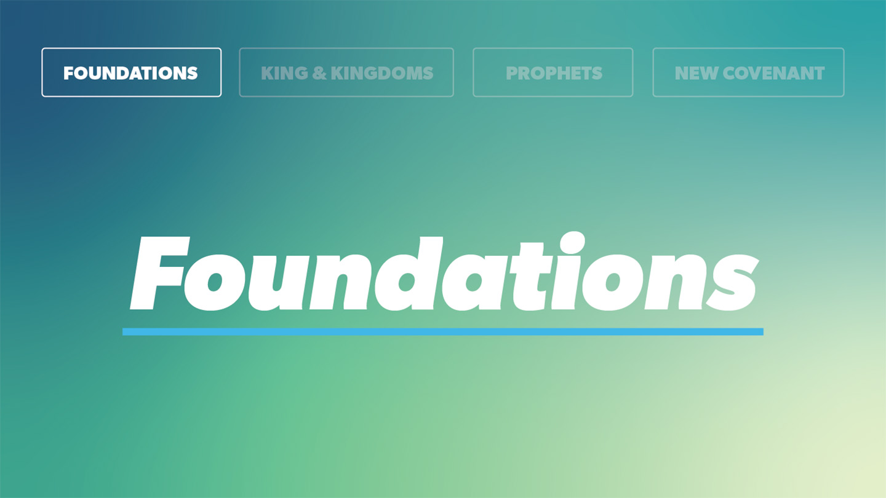

OPEN THE CONVERSATION
Take some time to build relationships with the students:
- Ask for each student’s high and low from the week.
- Today’s RBQ: If you could have one fictional character’s special ability or power for a week, whose would you choose and what would you do with it?

INTRODUCTION
If you’re a comic book fan or you’ve ever seen the Avengers movies, you probably remember Thor and his famous hammer. Forged in the heart of a dying star, Thor’s hammer was no ordinary weapon. It allowed the one who possessed it to wield incredible power and because of this could only be lifted by someone who is “worthy.” While the story of Thor makes for an exciting superhero movie, today we’re going to read about someone real, whose worthiness matters infinitely more. In Revelation 5, we see Jesus, the true Savior, as the only One worthy to accomplish God’s plan, rescue His people, and receive the worship of all creation. Today, we’ll discover what makes Jesus worthy and why His worthiness changes everything about how we see and live our lives.

Recap: What have you learned in our study of Revelation so far?

READ REVELATION 5:1-14

- What does it mean to deem someone worthy of a certain role or task? What does it say about Jesus that He is the only one who was found worthy?
- Scholars generally interpret the scroll to represent God’s perfect plan for all creation. John’s emotional response shows us how deeply he desired God’s plans to unfold. Where would you rate your current level of desire for God’s plans and Kingdom to be done in your life? Is it something you seek daily? Why or why not?
- The passage calls Jesus both the “Lion of the tribe of Judah” and the “Lamb who was slain.” What do these descriptions remind us about His identify? Why is it important we recall these truths often?
- How does the picture presented in verse 8 shape the way you think about the value of prayer?
- How did those surrounding him respond to Jesus when he took the throne? If you really believed that Jesus is worthy of your whole life, what might change about the way you think, live, or make decisions this week?

WRAP UP
Put today's lesson into action: How do you need to respond to Jesus this week as a sign of His value in your life?

Ask for any prayer requests, and pray for one another.
EXTENDED CUT
Leader Note & Context: The Book of Revelation is rich with imagery that is often hard for the uninitiated reader to interact with. However, most of these difficult texts are about one basic concept—for Revelation 5, it is worship. Everyone worships something—that’s how we were designed. But in our sinfulness, we often choose to worship things like achievement, money, other people, or even our favorite sports team.

In today’s passage we’ll continue John’s vision in the heavenly throne room. The throne room of God is the ultimate expression of worship. Here John sees a sealed scroll with writing on both sides. Such a doubly inscribed scroll would likely resemble a Roman will or contract deed, with the contents written in detail inside and summarized briefly outside, then sealed securely until it was the right time to open it publicly. Ancient legal documents usually had about six witnesses. This scroll had seven, which is the number of perfection (of fullness and completeness) in the Bible. Scholars generally interpret the scroll to represent God’s perfect plan for creation. Dr. Warren Wiersbe understands the scroll to represent the “title deed” belonging to Christ because of His redemptive work on the cross. Only an appointed heir can open a title deed, and the heir in this case is Christ Jesus.

The scene of Revelation 5 can be overwhelming, but in today’s lesson you can help students understand that we don’t need to absorb or understand every detail. The most important thing for us to take away here is that Christ is all-powerful, all-knowing, victorious, and He is worthy.

- What does it mean to deem someone worthy of a certain role or task? What does it say about Jesus that He is the only one who was found worthy? A helpful way to think about worthiness is that it means someone has the character, ability, authority, or qualifications needed for a particular role. For example, when you try out for a team, you typically have to demonstrate your ability to a team of coaches or judges. They determine whether you are worthy of making the team based on whether you have what it takes. In Revelation 5, the question isn’t simply, “Who is strong enough?” but “Who is worthy to carry out God’s purposes?” Who has the right character, authority, and qualifications? At first, it appears that no one – in either heaven or earth meets the standard for this holy task. And it causes a moment of deep grief that God’s perfect plans for the world may be lost. But then Jesus appears and everything shifts, because he is worthy! Jesus alone is worthy because of who He is and what He has done. He is the perfect Son of God who conquered sin and death and gave His life to redeem people for God. And that’s why the entire scene ultimately turns into worship. Jesus alone deserves the honor, authority, and praise of all creation – including us!

- Scholars generally interpret the scroll to represent God’s perfect plan for all creation. John’s emotional response shows us how deeply he desired God’s plans to unfold in the world. Where would you rate your current level of desire for God’s plans and Kingdom to be done in your life? Is it something you seek daily? Why or why not? If the scroll held God’s perfect plan for creation, the world’s destiny, and God’s plan for redemption couldn’t be fully realized until it had been opened. It’s no wonder John wept! He deeply desired and knew how desperately the world needed God’s plans to unfold. As followers of Jesus, we should have the same growing desire. Philippians 3:20 reminds us, “our citizenship is in heaven.” Therefore, we live with a different perspective and set of values, than the world around us. Because our identity is now found in Christ, we are called to “seek the things above” and set our minds on heavenly things rather than being consumed by the passing treasures here on earth (Colossians 3). We’re called to live for something bigger than just ourselves. To desire God’s will, seek His kingdom, and trust Him with our lives. On a practical level, this means we must daily practice seeking him in our thoughts, decisions, and actions. We don’t simply ask “What do I want?” but we ask God instead, “What do you want for my life?” It’s a daily surrender that if we’re honest, can be difficult! But we can be encouraged by remembering Jesus’ words in Matthew 16:25, “Whoever loses their life for my sake, will find it.” We are citizens of another kingdom with far greater things to come than anything the world has to offer.

- The passage calls Jesus both the “Lion of the tribe of Judah” and the “Lamb who was slain.” What do these descriptions remind us about His identify? Why is it important we recall these truths often? “The Lion of the tribe of Judah” is a name that echoes Jacob’s blessing on his son, Judah, in Gen 49:9-10. His words are a messianic prophecy that point toward the descendent of Judah who will one day rule the earth. That descendent is revealed here to be Jesus. He is the true king and the One to whom belongs the long-awaited obedience of nations (Gen 49:10). Yet it is not His fierceness or the force of His power that makes Him worthy. The Lion has triumphed because He became a Lamb. Sacrificed Passover lambs once saved God’s people from death in the plague of the firstborn in Egypt (Exodus 12), and Jesus’s sacrifice saves us in a more complete way. He lived a perfect, sinless life and in shedding His blood defeated sin and death. These two descriptions capture the complete picture of the Gospel and what Jesus has done for us, which is why it’s important we recall them often! When we regularly remind ourselves of the Gospel, it keeps our hearts grateful and cultivates a heart of worship, just like we see throughout this passage. It’s when we forget what Jesus has done, that we often begin to drift. We forget our identity as loved and chosen children of God redeemed by His grace, and we start to lean on our own understanding and strength instead. The more we remember the Gospel, the more our lives become a response of gratitude and worship to Jesus.

- How does the picture presented in verse 8 shape the way you think about the value of prayer? Verse 8 gives us a picture of golden bowls filled with the prayers of believers being lifted up as an act of worship. It’s important to note the word translated “saints” in this verse, isn’t intended to be exclusive. It is for all believers. Meaning every single prayer matters to God and is a way that we honor him. When we pray, we are acknowledging that Jesus is worthy, that we need Him, and that we trust Him with what matters to us! That means there is no such thing as a prayer that is too small or unimportant to bring to God. Whether we’re asking for help with a difficult situation, praying for a friend, confessing sin, or simply thanking God, He cares about what is on our hearts.

- How did those surrounding him respond to Jesus when he took the throne? If you really believed that Jesus is worthy of your whole life, what might change about the way you think, live, or make decisions this week? When Jesus takes the scroll, heaven erupts in worship. The elders fall before Him, the angels join in praise, and eventually every creature in heaven and on earth declares His worthiness. Their response makes sense because they recognize who Jesus is and what He has done. He alone is worthy of their worship! When we truly believe Jesus is worthy of our whole lives, it means Jesus isn’t just someone we worship on Sundays. He becomes the One who shapes our everyday choices and thinking. We begin to filter life through the lens of what would honor Jesus, and it influences things like how we act in our friendships, how we spend our time, what we do online, how we respond to pressure, and what we pursue. When we recognize that Jesus is worthy of everything, we begin to live like our whole life belongs to Him.

