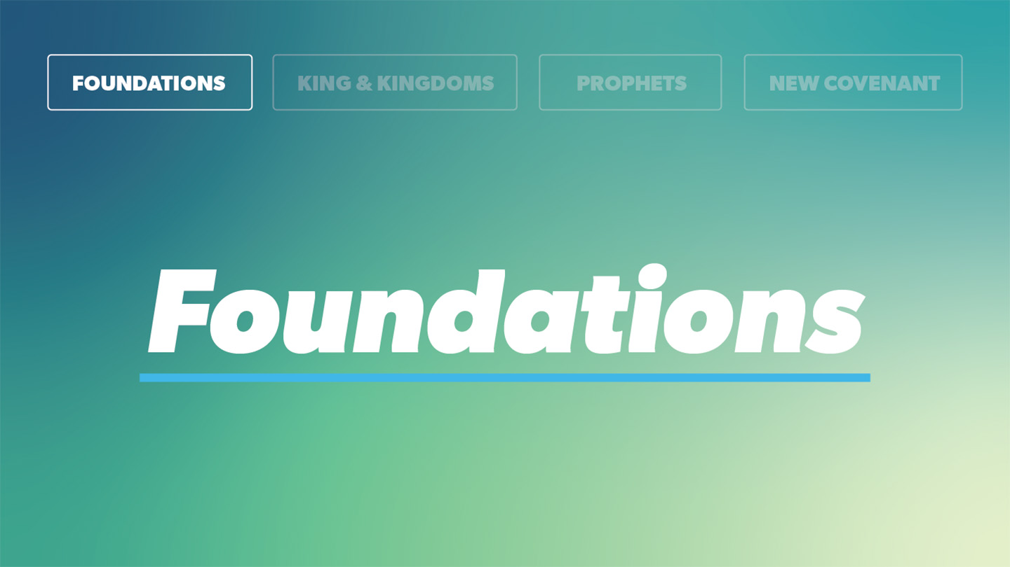

OPEN THE CONVERSATION
Have you ever received a correction or rebuke from parents, grandparents, or a teacher or coach that was hard to swallow? What changes when you realize it comes because you are loved by that leader?
INTRODUCTION
Parents, whether they are good at communicating it or not, are motivated by love and a deep sense of responsibility to steward us well. Many coaches and teachers are likewise willing to initiate hard conversations if they believe it will help us grow.
Can you point to a hard conversation a parent, teacher, coach, or Lifegroup leader had with you that was hard at the time, but you are grateful for now?
Ephesians 5:1-2, and 5:25-26 emphasize Jesus’ love for the church—for the people that make up the church. He proved this love by giving Himself totally for the church. (There could be no church without the salvation He offers!) In Scripture we see the comparison of the depth of His love to that of a husband, and a good father and caring shepherd. So, when we read the messages Jesus sends to the churches in Revelation 2 and 3 we can know His words come from a heart of true and proven love.
We will see that Jesus’ words in these two chapters of Revelation are for us today, too. Pause and pray for the Holy Spirit to speak clearly to your heart through these passages, and to help you receive the Scripture with humility.
READ Revelation 2 and 3, pausing after Jesus’ message to each church to discuss (outlined below).
Create a grid chart for the group to fill in as the discussion unfolds. Across the top of the page write, “Affirmation” “Correction” “Promise” and “For Us Today” to head each column. Down the left side of the page list the names of the 7 churches.
Work your way through the 7 letters, filling in the chart together as you go. Involve as many group members as possible in the reading and discussion.
Notice any differences or nuances between them and follow lines of questioning that emerge.
What do you think the phrase “Anyone who has an ear should listen to what the Spirit says to the churches” means?
[Create your own grid above as part of your study/prep time working through the Scripture. Use it as a guide to pray for our church family and the global church this week.]
WRAP UP

Think about all you have seen and discussed today as you go to worship and hear the sermon. How has this section of Revelation come to life for you today?
How can you apply it to your daily life?

How each of us lives out our faith impacts the whole church family, and affects the personality/character of our local church. What could you adjust this week to have a more Christ-like impact in our church family.
Ask for any prayer requests, and pray for one another.

EXTENDED CUT
Ephesus. Ephesus was a large and powerful city in the ancient Roman Empire, heavily devoted to Artemis worship. This fertility goddess (who they called “savior”) had a massive cult presence in the city (the temple for Artemis even functioning as a bank). You may recall Paul’s extended ministry there, as recorded in Acts (Acts 20:31). We also have Paul’s letter to the church at Ephesus (Ephesians). The Ephesian church was praised for their hard work. They didn’t tolerate evil people and had tested false apostles and “found them to be liars” (v. 2). They hadn’t grown weary in their perseverance for Christ. But they’d lost their love for God and had failed to follow what Jesus called the greatest commandment (Matthew 22:36-38). This does not mean they had lost their salvation (thankfully, this is not possible), but they were in serious need of change. “In these words, the faithful were promised spiritual rewards. The “tree of life” and the “paradise of God” refer to the new heavens and new earth (Revelation 22:2), a reward awaiting all believers.
Smyrna. Smyrna was a port city north of Ephesus. The large Jewish community there strongly opposed Christianity, which Jesus acknowledged. When the emperor, Domitian, rolled out the edict saying everyone must worship him, he exempted the Jews, who did not want this freedom to extend to the Christians. Unlike the other churches, those in Smyrna received only commendation from Christ. They suffered opposition from the Jews, who were slandering them. The description of the Jews in verse 9 doesn’t mean they weren’t of Jewish descent but rather points to their uncircumcised hearts (Romans 2:28-29). Their spiritual warfare would continue with a short prison stay to test their faith, but the reward for endurance would be “the crown of life” (v. 10; James 1:12). The “second death” refers to the “lake of fire” in Revelation 20:14 (Revelation 20:10,15). But faithful believers will “never be harmed” by t his (v.11).
Pergamum. The ancient city of Pergamum was about fifty miles north of Smyrna. Christians were harshly persecuted there for their “disloyal and unpatriotic” refusal to participate in Domitian’s emperor worship. Jesus’s note of “Satan’s throne” (v. 13) was a reference to the centrality of emperor worship in their culture. This was a difficult place for believers to live (even worse than Smyrna). The “sharp double-edged sword” (v. 12) is also referenced in 1:16, symbolizing the Word of God’s power to judge. In His commendation, Jesus acknowledged the difficult environment these believers found themselves in and commended the people for holding onto their faith. They didn’t even deny Him when a faithful believer, Antipas, was martyred. Yet, they allowed the Nicolaitans, heretics who taught idolatry and immorality8 embraced by their society, to place a stumbling block in front of them. Jesus called for their repentance. The “manna” referenced in verse 17 pointed to Jesus’s care of the people. White stones were given victors in the athletic games of the ancient Greeks, allowing them to retire and might be in view with the closing reference to this church.
Thyatira. Thyatira sat on the Lycus River, about thirty miles southeast of Pergamum. Its trade guilds were devoted to patron (little g) gods and goddesses, and a huge pressure existed there for Christians to participate in a culturally acceptable lifestyle of idolatry. Thyatira, whose letter is featured in the middle of this set of letters, was the smallest city written to, but received the longest letter. This is the only time in Revelation that Jesus is called “the Son of God” (v. 18). The imagery in verse 18 points us back to Revelation 1:14-15.10 The church was commended for their “love, faithfulness, service, and endurance” (v. 19). Jesus criticized these believers for partaking in the pagan culture that surrounded them. They were behaving in a sexually immoral manner and eating meat that had been sacrificed to idols (the New Testament warned against this). Jezebel is a callback to the evil queen of Israel in the time of the kings (1 Kings 16, 18, 19, 21). She, along with her husband Ahab, promoted idol worship and actively persecuted God’s church, leading the people down an unfaithful path. Her “children” (v. 23) referenced the called out unfaithful in the congregation. Just like the people in the days of Jezebel were called to repent, so were the people of Thyatira, though apparently not everyone was unfaithful (v. 24). The faithful will enjoy ruling with Christ at His second coming (Revelation 20:4,6).11
Sardis. Sardis was one of the oldest cities in Asia Minor. The people there were obsessed with death and immortality, and worshiped Artemis. The people of Sardis received no commendation from Christ, only criticism. They were living, but spiritually dead. We aren’t saved by our works, but good works flow out of genuine faith. Yet, this was missing from the people of Sardis. They needed deep spiritual change, and this letter served as a wake-up call. They were to remember God’s blessings and earnestly repent. Some among their congregation were faithful, but their numbers were few (v. 4). The faithful were worthy of heaven and their names would be recorded in the book of life.
Philadelphia. Philadelphia was about forty miles southeast of Sardis. After a devastating earthquake in AD 17, the people carefully planned for the future (and any earthquakes it held). Evidently, they also faced Jewish opposition similar to the church in Smyrna. Jesus is described here as Holy and true, almighty in authority and power. The “key of David” is a reference to Isaiah 22:22. The believers in Philadelphia were praised for their faithful works. Even though they had little power, they were faithful. Whatever injustice they faced, Christ would make it right (v. 9). Scholars aren’t agreed on the meaning of “keep you from the hour of testing” (v. 10), this could mean that they would be removed before the time of tribulation begins (7:14), or that they will be protected within it. “Those who live on the earth” (v. 10) refer to non-believers.
Laodicea. Laodicea was an ancient trade center famous for its textiles. Idol worship, Zeus especially, flourished in Laodicea. They also had a water problem. They didn’t have direct access to the cold water available in the mountains, or the nearby hot springs. They had to bring in their water, and when it arrived, it was lukewarm. Like their water, the faith of the Laodiceans was lukewarm. It was worthless and not genuine. Jesus wrote that He would spit them out (like you might a sip of lukewarm water). Their wealth lulled them into a false sense of security. They thought they didn’t need anything and didn’t realize that their need was actually great. They needed to repent and turn to true faith. Jesus had been metaphorically locked outside the door in Laodicea, but He was at the door, knocking and ready to enter again when they repented. He also promised that the faithful would one day reign with Christ.

