Basic CareLife Information to Prepare and Capture Notes for Hospital Visits
Web Link: https://brentwoodbaptist.ministryplatform.cloud/apps/carelife
STEP 1: Filter to only hospital visits by typing “HOSP” in search bar
STEP 2: Click or tap the desired case
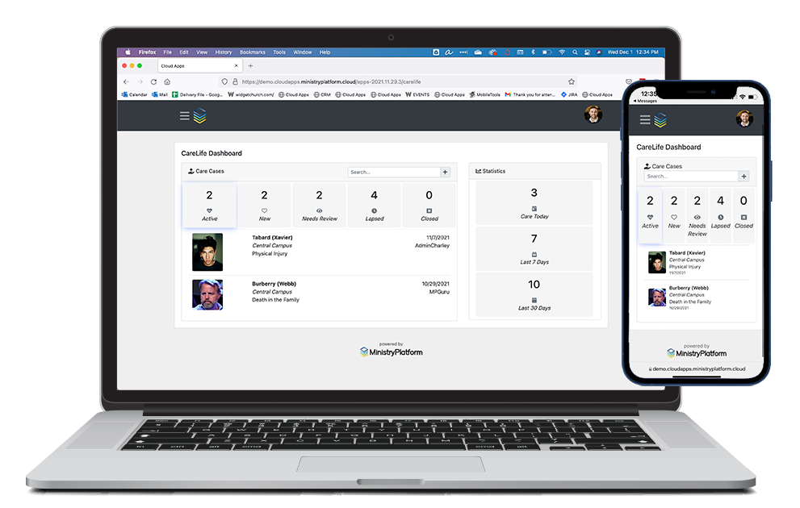
HOSP
HOSP

STEP 3: Review Care Case Details then navigate to “Care Log”

STEP 4: Review Care Log from prior visits. Click View to see each Deacon’s notes

STEP 5: Use menu to “Add Care Log” enter all info and click “Save Changes”!!!
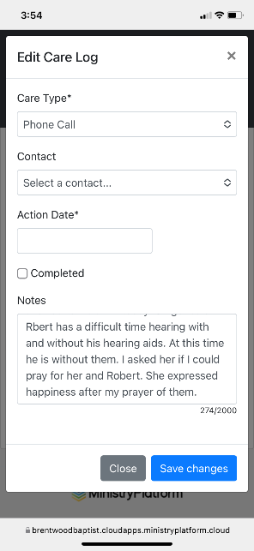
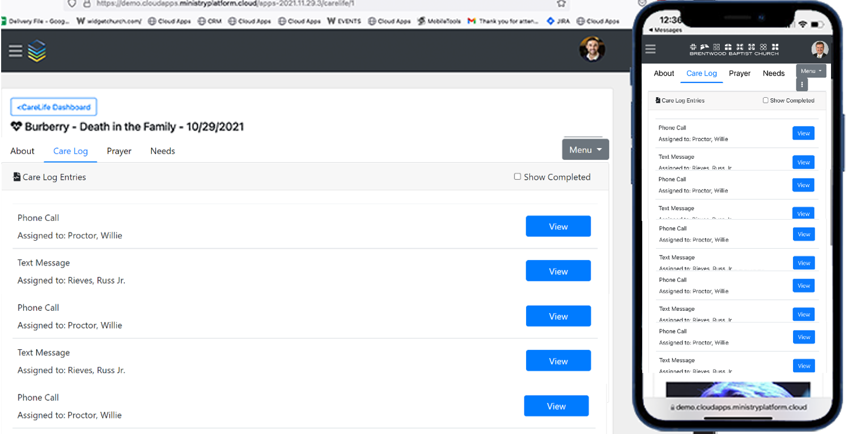
We had a good visit at the hospital. He is improving and in good spirits. We prayed together.
We had a good visit at the hospital. He is improving and in good spirits. We prayed together.

